# A REPORT ON DHAROHAR – LIDAR SCAN PROCESSING SOFTWARE

# AND SATELLITE IMAGE SEGMENTATION USING TRANSFER LEARNING ON

# UNET DEEP LEARNING ARCHITECTURE

AKSHIT KHANNA 2017A7PS0023P

ANAND THEERTHA 2017B3A70660G

ITI SINGH 2017B3A70545P

RAGHAV BANSAL 2017A3PS0196P

ABDULKADIR KHIMANI 2017B4A70696P

**AT**

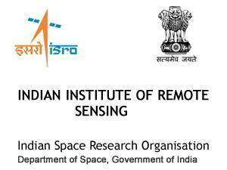

**A Practice School - I station of**



**BIRLA INSTITUTE OF TECHNOLOGY AND SCIENCE, PILANI**

**JULY 2019**

# ACKNOWLEDGEMENTS

This project, along with the entire Practice School experience, has been a great learning experience for every one of us. To all the people who made that possible, we extend our heartfelt gratitude and appreciation.

Firstly, we thank Dr. Prakash Chauhan, Director of IIRS, Dehradun for giving us this wonderful opportunity and providing us with all the necessary facilities.

We extend our most sincere gratitude to Mrs. Shefali Agarwal, Head of PRSD Department, IIRS, for providing us with the opportunity to work with her on this project. We would also like to thank Mr. Shiva Reddy, Mr. S Raghavendra, Dr. Poonam Tiwari and Dr. Hina Pande. Their professional guidance, incessant support and useful insights helped us learn constantly, and shaped our project into its final form.

In addition, we wish to extend our gratitude to our PS Instructor, Dr. Prateek Kala, Assistant Professor at BITS, Pilani – Pilani Campus, for his guidance and advice. We thank the staff at IIRS, Dehradun for being so very helpful at all times.

# BIRLA INSTITUTE OF TECHNOLOGY AND SCIENCE PILANI (RAJASTHAN)

## PRACTICE SCHOOL DIVISION

**Station**: Indian Institute of Remote Sensing **Centre**: Dehradun

**Duration**: From 23rd May, 2019 to 13th July, 2019

**Date of Submission**: 11 July, 2019

**Title of the Project:** 3D DIGITAL DOCUMENTATIONSOFTWARE DEVELOPMENT FOR DIGITAL HERITAGE ASSESSMENT USING RANGING AND OPTICAL DATA.

**Name of the experts:** Mrs. Shefali Agarwal, Dr. Hina Pande, Dr. Poonam Tiwari, Mr. Shiva Reddy, Mr. S. Raghavendra

**Designation**: Head of the department, Photogrammetry and Remote Sensing Division

**Name of PS Faculty**: Mr. Prateek Kala

**Project Area**: LIDAR Scan Processing, Image Processing, Database Management

**ABSTRACT:** The Project is an open source tool for the digital documentation of heritage sites. It allows the user to perform various tasks by signing in to the software with the help of credentials provided by the administrator. After authentication the user can access functionalities like Point cloud processing, Image processing, getting the views of heritage site with the help of FreeCAD and Database querying, which are organized in a simple tool. For this, the user should be equipped with elementary knowledge of computing and point cloud handling.

Point cloud processing and Image processing provides several features like Edge Detection, Corner Detection, RGB to HIS, HIS to RGB, Texture Analysis and Change Detection and Crack Detections. The software can also convert 3D point cloud to a 2D image whose point and image attributes can be stored in the PostgreSQL database and visualized by the user through interface. Moreover, 3D point cloud data can be stored in compressed patches in a database with the help of database querying. This 3D data can be visualised in a segment or as a whole in both high and low resolution. The project uses python and C++ as programming languages. For database querying, PostgreSQL has been used.

**TITLE PAGE NO.**

1. ABOUT THE ORGANIZATION 5

2. OBJECTIVE 6

3. SCOPE 6

4. REQUIREMENT ANALYSIS6

4.1 INTRODUCTION 6

4.2 REQUIREMENT SPECIFICATION 9

4.3 HARDWARE AND SOFTWARE REQUIREMENT 9

4.4 FEASIBILITY ANALYSIS 13

4.5 PRODUCT FUNCTIONS 14

5. GLCM TEXTURE ANALYSIS FOR 2D RASTER 33

6. GLCM TEXTURE ANALYSIS FOR 3D POINT CLOUD 40

7. PLANE FITTING ON 3D POINT CLOUD DATA 46

8.1 ADMIN ACTIVITY DIAGRAM 50

8.2 HIGH LEVEL SYSTEM DESIGN 50

8.3 USER CASE DIAGRAMS 51

9. APPENDIX 52

10. REFERENCES 62

**1. ABOUT THE ORGANISATION**

**Indian Institute of Remote Sensing (IIRS)**

The Indian Institute of Remote Sensing (IIRS) - an ISO 9001:2008 institute, is a constituent unit of Indian Space Research Organization (ISRO), Department of Space, Govt. of India. Since its establishment in 1966, IIRS is a key player for training and capacity building in geospatial technology and its applications through training, education and research in Southeast Asia. The training, education and capacity building programmes of the Institute are designed to meet the requirements of Professionals at working levels, fresh graduates, researchers, academia, and decision makers. IIRS is also one of the most sought after Institute for conducting specially designed courses for the officers from Central and State Government Ministries and stakeholder departments for the effective utilization of Earth Observation (EO) data.

To widen its outreach, IIRS has started live and interactive Distance Learning Programme (DLP) since 2007. IIRS has also launched e-learning course on Remote Sensing and Geo-information Science since August, 2014.

The Institute has a strong, multi-disciplinary and solution-oriented research agenda that focuses on developing improved methods/ techniques for processing, visualization and dissemination of EO data & Geo-information for various societal applications and better understanding of Earth's system processes. Currently, Microwave, hyper spectral and high-resolution EO data processing and their applications are some of the prime research areas. State-of-the-art laboratory and field-based instrumentation and observatories network help meeting the research goals and objectives.

IIRS hosts headquarters of Centre for Space Science and Technology Education in Asia and the Pacific (CSSTEAP), affiliated to the United Nations and provides support in conducting the Remote Sensing and GIS training and education programmes. IIRS also plays a key role in the activities of Indian Society of Remote Sensing (ISRS), which is one of the largest non-governmental Scientific Societies in the country.

**2. OBJECTIVE**

Thе objective of this project is to make an already existing application morе еfficiеnt. The proposed system includes some added functionality to the existing system like:

* 2D GLCM Texture Analysis
* 3D GLCM Texture Analysis
* Best-fit plane detection
* 3-D documentation of cultural heritage sites which include:
* Storage of 3D point cloud in a database
* Subsetting and Retrieval of point cloud data from database
* Making the software more user friendly by simplifying data handling

This project allows the user to store 3D point cloud data in the database. It also incorporates the facility of subsetting the point cloud data and viewing the selected data to perform further manipulation. So, instead of manually viewing the entire point cloud, the user can get the point cloud data of a selective area of a building and process it to find abnormalities like cracks and take further steps to recover it. The project also allows the user to do 2D GLDM texture analysis and find the best plane fit further used for edge detection. An attempt was also made for 3D GLCM texture analysis and improvements can be done in the future.

**3. SCOPE**

This Project is basically a standalone application that runs on an individual’s personal computer. The user needs to download every required interface and software on the system. The user-friendly environment of the application allows the user to easily store 3D point cloud data and retrieve a selected portion of that data for further analysis. Without viewing the entire point cloud, the user can select a portion and apply image processing techniques on the subset of data.User can perform 2D GLCM texture analysis for assessment.

**4. REQUIREMENT ANALYSIS**

**4.1 INTRODUCTION**

The heritage sites are of cultural importance to any country. However, they are often damaged by natural or man-made threats like floods, pollution, earthquakes, fire and urbanization. Thus, these sites need to be maintained in order to sustain them over centuries. Precise documentation of heritage sites is essential for their protection. The documentation also aids the scientific studies that are carried out during the restoration and renovation process. Although the documentation process can be done manually, it is a time consuming and expensive process. At times certain damages may go unnoticed due to human error or lack of appropriate tools and equipment. With the advancement in remote sensing techniques and information technology, this maintenance can now be done in an easier, reliable, non-invasive and cost effective way. These technologies have shown a great potential for monitoring and even discovering heritage sites. However, the spatial data provided by remote sensing technologies needs to be interpreted by some sophisticated tool. For this purpose there is a need to build a user-friendly application that can document the condition of a heritage site and detect any damage that has occurred to it over a period of time.

The project deals with the development of software that can store 3D point cloud data, retrieve a subset of that data and analyze, detect and report about the changes and damages taking place or tending to occur over time. This would ensure the proper maintenance of the heritage sites. The software requires the point cloud data from the Aerial LiDAR (Light Detection and Ranging) Laser Scanners for any heritage site. This point cloud data can give a 3D image of the entire site. This data can be stored in a database and analyzed for changes over different time by comparing two or more LiDAR data taken at different points of time. The software can also retrieve the 3D data of a particular area of the heritage site which will lead to a better and more detailed analysis.

The software can alert the user about damage in several ways. The changes in the edges and corners of building can be detected by it. It can also analyse texture of the building and report about serious issues like algae growth, moisture accumulation and weathering with the help of 2D GLCM texture analysis. It can also find the best plane fit for detection of cracks. Hence the user only needs to provide point cloud data to the software which can perform all the necessary operations.

The user must have an elementary knowledge of computing and point cloud data handling to work on the software. Some knowledge about programming languages C++ and Python is required Apart from this, the system on which the software runs must have specific software installed in it. Also, the software cannot display very large point cloud data as a whole to the user. In this case, the user can study only a segment of the data at a time.

# NEED FOR DHAROHAR

There are many software available in the market for digital documentation of the heritage sites. However, there was no single software that performed all the necessary operations. The use of multiple applications leads to much inconvenience and loss of data. So IIRS decided to create a standalone application that performs all the operations at one place. This concept was called DHAROHAR. DHAROHAR stands for Digital Health Assessment using Ranging and Optical Data for Heritage and Archaeological Restoration.

DHAROHAR gives the user three major functionalities organized in a simple tool:

1. **Point cloud processing:** Under point cloud processing the user can visualize, translate, rotate, register, and rasterize 3D point cloud data i.e. convert it into 2D format.
2. **Image processing:** It allows an analysis of texture and detection of edges, cracks, and textures.

**3. Database querying:** It includes functionalities like User Registration, User Login, and Administration maintenance of Users. The data can be stored into five formats; Raster, Matrix, Image, 3D Point Cloud, and Patch. This data can then be retrieved for further processing.

These functionalities will be discussed further in detail in upcoming chapters.

To develop this application, the following Programming Languages were used:

**1. C++ and QML:** The User Interface has been developed with the help of QtCreator. QtCreator is an Integrated Development Environment (IDE) that provides tools to design and develop an application with the Qt application framework. It mainly uses C++ compiler from GNU Compiler. QML is a user interface markup language used by QtCreator.

**2. Python:** Python is open sourced, easy to understand, highly readable, and has a powerful syntax which made us choose it.

**3. PostgreSQL:** The database parts with its queries have been written using PostgreSQL.PostgreSQL is used as it contains geometry data types like point, polygon, and line.

**4. CSS:** The UI designs and its style sheets have been accomplished using CSS.

**REQUIREMENT SPECIFICATION**

In addition to the hardware and software requirements, the user must possess knowledge of image and point cloud processing concepts. The user must also be equipped with the basic knowledge of programming languages like C++ and Python.

**4.3.1 HARDWARE REQUIREMENT**

* **RAM:** At least 4 GB
* **HDD:** 5 GB or more (Free space excluding data size)
* **Processor:** Intel(R) Core (TM) i3(or equivalent) @ 2.70GHz or greater.

|  |  |  |
| --- | --- | --- |
| **Software** | **Type/Platform** | **Version** |
| **OS** | **Windows OS** | **Windows 7 and above** |
| **Qt Creator** | **Microsoft Visual Studio 2013** | **QtCreator 4.0.1 Based on Qt 5.6.1(MSVC 2013,32 bit)** |
| **OpenCV** | **Microsoft Visual Studio 2014** | **OpenCV 3.2.0-vc14** |
| **Cmake** | **Qt 3.6.0** | **Cmake 3.7.2** |
| **Python** | **-** | **Python 2.7** |
| **PostgreSQL** | **-** | **PostgreSQL 9.4** |
| **PostGIS** | **PostgreSQL 9.4** | **PostGIS 2.2** |
| **GDAL** | **-** | **GDAL 1.1** |
| **Python wheel files** |  | **GDAL, matplotlib, numpy, pygame, PyQt4, scikit-image, scikit-learn, scipy, secure-smtplib, affine, imutils, pandas, psycopg2, cx_freeze, open3D** |
| **PostgreSQL Extension** |  | **Pointcloud, PostGIS, Pointcloud_postgis** |

Table 1: Softwares with their required platform and version

The software mentioned above and their functions shall now be discussed in detail :

**QT Creator:**

Qt Creator is an Integrated Development Environment (IDE) that provides the tools to design and develop software applications. Qt can design and develop applications and graphical user interfaces (GUIs) once and deploy them to several operating systems. Qt Creator provides software developers various tool to customize widgets and test them directly. In the case of DHAROHAR, Qt Creator is used to design the user interface and add functionality to its components like buttons, textboxes and checkboxes.

**OpenCV:**

OpenCV is an open source library that supports a lot of algorithm related to Machine Learning and Computer Vision. Algorithms of OpenCV can be used to track movements, detect objects, produce 3D point clouds and stitch images together. OpenCV is supports various languages like Python, C++, Java and runs on multiple platforms like Windows, Linux, Android and iOS. OpenCV is required for visualization purposes in DHAROHAR.

**Cmake:**

Cmake is an open source tool which is designed to build and test a software package. It compiles the source codes using simple platform independent configuration and generates makefiles for the software accordingly. User can also test the source code with the help of CMake. Cmake is required to generate build files for DHAROHAR software package.

**PostgreSQL :**

PostgreSQL is an open source relational database management system (RDBMS). It has been in active development for more than thirty years. It is known for its reliability, speed, and the support of an active community. It supports most of the standard SQL data types like INTEGER, VARCHAR, TIME, DECIMAL, and DATESTAMP. Apart from this, PostgreSQL also supports geometric data types like POINT, BOX, CIRCLE, and POLYGON. It can run on well-known and widely used programming languages like JAVA, Python, C/C++, Perl and RUBY. In DHAROHAR, PostgreSQL is used to store 3D point cloud data in the form of patches. It also stores raster images in JPEG format. The database queries our executed with the help of Python.

**PostGIS**

PostGIS is a spatial extension for PostgreSQL. PostGIS contains additional geometry data types for POINTS, POLYGONS, LINESTRINGS and MULTIPOLYGONS. It also has various functions which can perform geometric operations like calculation of area, perimeter, shortest distance, and spatial set operations. We can create a spatial database in Postgres with the help of PostGIS. PostGIS can be installed with the help of Stack Builder application which is included in the Postgres package. PostGIS is needed by the application to save spatial data.

**PyQT4:**

PyQt4 is a python library which is supported by Python version 2 and version 3. PyQt provides Python bindings for the Qt framework. With the help of PyQT, the developer can use graphical user interface (GUI), network communication, database querying, XML handling, Web browsing, and other technologies available in Qt in python programs.

**Python2.7:**

Python is a high-level programming language (HLL) widely used for software development and web development. It can run on different platforms. It is easy to understand and its programs require fewer lines of code. Python is used as one of the programming languages to develop DHAROHAR. Since Python also supports various complex mathematical functions and their graphs, it is suitable for performing image processing techniques. Python can also handle big data. In DHAROHAR, image processing techniques are performed with the help of various python libraries. It is also used to handle big data. The database queries are run with the help of python.

**GDAL:**

GDAL is an open source library that deals with vector and raster geospatial data formats. It also comes with utilities required for translating data into vector and raster format and processing it. GDAL is needed for rasterization of 3D point cloud and storing it in the database.

Apart from hardware and software requirements, the user must have some qualifications to run DHAROHAR. The user must be computer literate with sufficient proficiency in English language. The user should have some basic knowledge about image processing and point cloud processing.

**4.4 FEASIBILITY ANALYSIS**

**Technical Feasibility:**

The project is technically feasible as all technologies used in the project are easily available. The Python and C++ libraries used in this project are open source and hence their source code is available on the internet.

**Schedule Feasibility:**

This project is feasible as this project was completed in available time, the schedule that was decided before the start of the project has been strictly followed and hence the project was completed in the given time.

**Economic Feasibility:**

This project is economically feasible as the software, libraries and language scripts used are open source and available on the internet free of cost. The project does not use any paid technology.

**Technical requirements:**

The hardware and software requirements to run DHAROHAR are very low. It occupies on;y 3GB of space. Python, QtCreator and its libraries being open sourced are easily accessible. Python programming language is easy to understand and its libraries can perform complex mathematical functions. The user can easily access the tool due to the Graphical User interface used in the software. The user need not to be proficient in computer programming.

**Profitability:**

DHAROHAR is a culmination of point cloud processing and image processing techniques. The graphical user interface makes it easier for the user to understand and use the software. The project aims to do a digital documentation of any monument. The extended objective of the project is to store 3D point cloud data in a database, selective retrieval of point cloud data, GLCM Texture analysis for 3D and 2D and plane fitting for crack detection.

**Need:**

As per the best of our knowledge, there is no software available that performs such diverse functions as a single application. Working on multiple software packages can create inconvenience for user and lead to loss of data in some cases. In this software, the GUI helps a user to follow instructions step by step without any confusion.

**4.5 PRODUCT FUNCTIONS:**

This section will describe the various functionalities provided by DHAROHAR. The first part deals with different features coming under database querying. The second part deals with Point Cloud Processing, and the third discusses Image Processing.

**Database Querying**

PostgreSQL 9.4 has been used as the backbone for the backend of the project. PostgreSQL is a powerful and suitable database management system for DHAROHAR. It can be combined with Python and PostGIS, which is a spatial database extender for PostgreSQL, to store and view various types of spatial data.

**Admin Login**

The Admin can store and manage information in the database. The admin needs to verify himself by entering the username, password, and database name in the login portal. All these entries are validated by checks. After the verification of the entries, the admin can add new users, manage users, create projects, and manage projects.

**User Login**

The admin has the authority to provide access to a user. In order to use the application, the user has to enter the username, password, and database name in the login portal. These entries are validated and verified. After successful verification, the user can create and manage projects.

The user can restore the password by contacting Admin.

e.

**Authentication-**

The authentication is necessary for confidentiality and security. Both normal users and Administrators need to verify themselves before proceeding with the tasks.

The user gets access to only manage his projects but the administrator an allowance to manage all the projects irrespective of ownership. Only the administrator has the authority to delete projects.

If the user forgets the password, he can request the administrator for a new password. Once the administrator changes the password, the user gets notified about it. This is done to maintain a two way security and prevent unauthorized modifications.

**Adding a User**

The administrator has the right to add a new user to the system. The Admin will provide username and password for the user. Admin also has the option of encrypting the password for better security. Apart from this, he/she can manage the users and their validity.

**Managing Existing Users**

Admin can change the password of the user with the help of username. He/She can update the details of user like validity and permissions. Admin also has the power to delete a user.

**Project Management**

All users and administrators get the authority to create new projects and manage existing ones. The Administrator can manage all the projects while the users can manage only those projects which are created by him/her or granted access by the administrators. Both users and administrators can grant another user the privilege to store and retrieve data from the database as well as revoke earlier privileges.

**User Management**

The Administration is the only one who gets the authority to manage users. He/She can add new users and manage existing users. Under the option of managing users, the administrator can extend the user validity, change and encrypt his pass, add him to a group, grant him the permissions to manage database and users. The administration can also delete an existing user or revoke his rights.

**Storage of Data**

The data can be stored into five formats which are Raster, Matrix, Images, LiDAR Data Storage as Patches and Points. The data can also be retrieved for processing.

**Database Creation**

In order to access the database, one needs to create the database, store data (image pixels and LiDAR Data) into it and then access and visualize it accordingly. All the properties and dimensions of the point cloud will be stored in the database and will be retrieved from the same for the purpose of visualization of the data. Values which can be stored in the database are:

**1. X,Y,Z Coordinate-**

The X, Y, and Z coordinates of the points of the point cloud will be extracted from the ASCII text file of point cloud and stored in the database.

**2. Band Pixels**

One or more layers in the raster data set are called bands. For example, a colored image contains three bands (red, green, and blue) while a digital elevation model (DEM) has only one band. Multispectral images can have several bands.

Each raster band contains the actual cell values, as well as some key properties, such as the histogram, minimum, maximum, and mean of the cell values, and a default colour map for displaying raster.

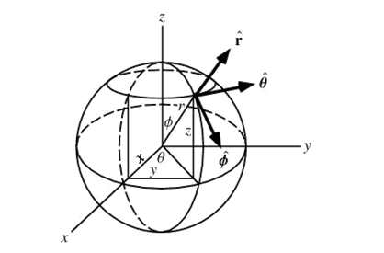

**3. Theta-**

Spherical coordinates or spherical polar coordinates are a system of [curvilinear coordinates](http://mathworld.wolfram.com/CurvilinearCoordinates.html) that are suitable for defining positions on a [sphere](http://mathworld.wolfram.com/Sphere.html) or [spheroid.](http://mathworld.wolfram.com/Spheroid.html) Theta or the Azimuth is an angular measurement in the spherical system. It is given by-

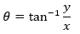

**4. R (Radius):**

Radius is the distance from a point to the [origin.](http://mathworld.wolfram.com/Origin.html) Mathematically, it is given by-



**5. Depth:**

Depth is polar angle given as ϕ = 90 – δ ,where δ is the latitude from the positive z-axis with

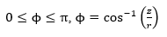

,

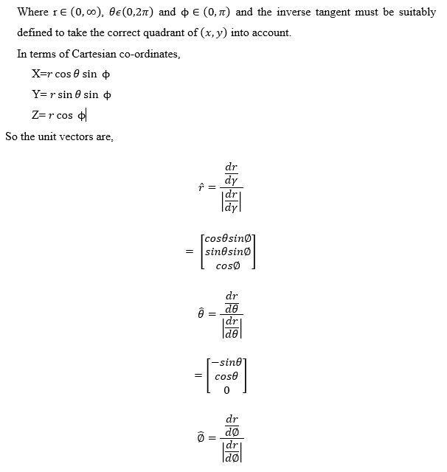

**6. Statistics:**

The function ST_SummaryStat supported by the PostGIS extension of PostgreSQL returns a summary stats consisting of count, sum, mean, stddev, min, max for a given raster band of a raster or raster coverage. Count count gives the number of pixels(n). Min and Max give the minimum and maximum pixel value respectively. Mean distance is the sum of distance divided by the number of pixels. Standard deviation measures the deviation of pixel distance from the mean pixel distance. It is given by-

standard deviation = 

where

n is number of all distances

Xi is the distance from point i to its next neighbour

Xm is the mean distance

**Storage and Retrieval of LIDAR Point Cloud Data**

A point cloud is a set of data points in space which display objects of the environment in a 3D format. A point cloud is generated by a 3D LiDAR scanner. The LiDAR scanner emits pulsed laser light and calculates object distances by detecting reflected pulses. LIDAR sensors can produce millions of points with large numbers of variables measured on each point. The variables might range from 3 simple features like the coordinates of the pointcloud to as far as 16 characteristics including the Intensity of R, G, B etc. Point clouds can also be produced using photogrammetry techniques but such point clouds are less accurate.

A point cloud can contain billions of points. So, the size of data file generated by the LiDAR scanner might be of an order of 100 GB. Hence, there was a necessity to store Point Cloud data in a compressed format without any data loss. This above problem was overcome with the help of ‘Pointcloud’ extension of PostgreSQL which efficiently stores the data with high fidelity access. This extension is open-source and available on GitHub for free. It is also included in PostGIS package. Apart from this, it's easy to build and install, and well documented. The extension also provided functions for the analysis and manipulation of Point Cloud.

In order to store point cloud data, the Pointcloud extension introduces two new data types- PC_Point and PC_Patch. The PC_Point takes the various variables associated with the point and stores them in a compressed form in one column. PC_Points can be converted into human-readable JSON form using functions provided by Pointcloud extension. In the pointcloud_formats table, an automatic table generated by the extension ,the meaning of each dimension in the of the point is explained. The underlying storage of the data might not be in integer form but on extraction it can be represented as an array of doubles. Although this reduces the size of point cloud data, the compressed data still contains billions of rows which is an efficient way of using the resources. To avoid this multiple points are grouped together and stored in a PC_Patch. This reduces the number of rows to millions. Although there are still millions of rows, this number can be managed by the database. PC_Patches can also be transformed into a human-readable form using various functions.

In general LiDAR data is difficult to store in some predefined format. This is because the 3D points generated by LiDAR scanners have multiple variables associated with them. The number of variables depend on the type of scanner used, its settings and capture process. As a result some data set might contain only coordinates while some may also have intensity as attributes. To accommodate this variation, the Point cloud extension uses a “schema document”. This document describes the variables associated with a particular LiDAR data set. It describes the name of the variables, their sizes, position and description. This schema also helps in interpretation of various attributes point cloud data during the process of retrieval.

In order to save the point cloud data the user has to select patch level which is the number of PC_Points to be grouped in one PC_Patch and then click on “Save to DB” button.

The Pointcloud extension automatically creates following public tables :

* pointcloud_formats table: Schema documents are stored in the pointcloud_formats table along with an identifier called pcid. Rather than store the whole schema information with each database object, each object just has a pcid, which helps to find the matching schema in pointcloud_formats.
* the pointcloud_columns view: It displays all the columns in the database that contain point cloud objects

**Optimizing the database:**

As Point Cloud data can be very large, storing it can take a lot of time. So, this storage process should be optimised as much as possible. PostgreSQL provide the feature of unlogged table which improves the write speed. This in turn reduces the time of storage and retrieval from the database. PostgreSQL is designed to be extremely protective of data which is expected by most of the users. It keeps track of changes in tables using WAL (Write-Ahead Log). This operation carries an overhead (additional disk IO) which substantially reduces the write performance. However, it guarantees that the table data is secured after an unclear shutdown. In case of unlogged tables, PostgreSQL does not record changes and this optimizes the write operation. But in this case, the tables are automatically cleared if the server crashes and hence unlogged table should only be used for inserting data in intermediate tables. Unlogged tables are not temporary tables as they are not deleted at the end of the current session. The data stored would persist and would not get corrupted, but it might be lost in the event of a crash. Unlogged tables are best used for large data sets (e.g. computation) with less usage, dynamic data with expiration time and volatile data that can be easily regenerated.

Another way to improve the performance is the use of nested queries. Nested queries use the result of one query as an input for the other. Nested queries break a complex query into isolated parts so that the logical parts of the query can be divided into a series of steps. This also reduces the time taken by reader of the current query to fetch the results of the previous query.

It has also been noticed that Input/Output file operations in some queries have better performance than the insert queries. If data size of the query exceeds the memory size allocated by the database during execution, a temporary file is created. There is simultaneous data transfer, first from the database to the temporary file and then back to the database. This slows down the speed of the insert command. However if we use the copy command to transfer data from an input file to database, no such temporary files are created. This takes less time and optimises the query.

**Storing LiDAR Point Cloud Data:**

In DHAROHAR, the Lidar Data is stored as patches into the database. Before the process of data storage, a valid schema must be created. The LiDAR data is converted into PC_Point format with the help of a valid schema and an array of decimal numbers that matches the schema. The points are stored in a compressed form as shown below:

SELECT PC_MakePoint(1, ARRAY[-127, 45, 124.0, 4.0]);

010100000064CEFFFF94110000703000000400

Once the points are converted into PC_Point format, they can be stored in a table in the database. The LiDAR data which had a number of columns is now reduced to the data with one column but the same number of rows as before. This data is then converted into PC_Patch where we group a certain number of rows into one row and store them in another table. Thus the storing of the data into the database with a reduced size can be done. The figure given below shows how several PC_Points are stored in PC_Patch.

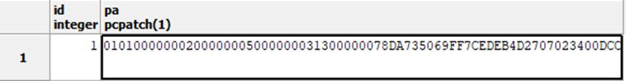

Using the above-mentioned concepts, the point cloud data is stored in DHAROHAR in a series of steps. First, the raw data is stored in an unlogged table with each dimension of the point in a separate column. Then this data is converted into PC_Point format, stored in another unlogged table and the table with raw data gets deleted. The PC_Points are then grouped together and converted into PC_Patches. These PC_Patches are stored in a separate table and the table with PC_Points gets automatically deleted. Although this process requires creation of two temporary tables which would occupy a large amount of memory, it is a fast one. Converting the raw data into PC_Patches directly and then inserting it into a table step by step would not require these temporary files but it is a time-consuming process for even small-sized data of few hundred megabytes. The figure below shows the process as a flow diagram.

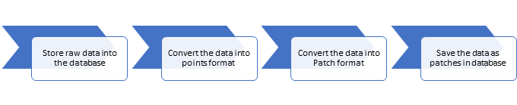

**Process Of Retrieval:**

After storing the data into the database in a compressed patch format, the process of retrieval can be done in many ways. The user can get all the raw points directly from the database to view and analyze the whole point cloud or fewer points defined either by maximum, minimum or the average of a certain number of points put together to rather view a primitive version of the pointcloud. The user can also view a subplot of the pointcloud by filtering the points based on the coordinates of the extreme points selected by him/her.

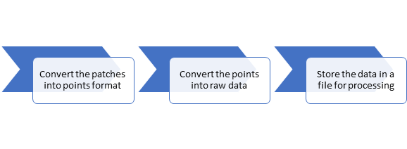

Each process involves the use of different functions which by the user will be able to retrieve the data from the database in human readable format. The final output of all these processes will be available in a file format which can be further used for point cloud and image processing.

One can directly get the PC_Point data from the PC_Patches ungrouping the patches using pc_explode() and then converting them into human readable format using pc_get() function.

The point cloud data can sometimes contain too much details and the user may only want to view a less-detailed point cloud. Also point cloud processing window of most softwares can show only a limited number of points at a time. To overcome these problems, the user must be given the option of choosing the Resolution. Resolution here refers to the amount of details a point cloud holds. With a low resolution, one can view the point cloud with a fewer number of coordinates so as to get a rough preview of the point cloud. It involves taking the average of all the points present in a particular patch. This average point replaces and represents a cluster of points. One can reduce the resolution with the help of the drop down box present in the interface window. The following figure shows two images with different resolution.

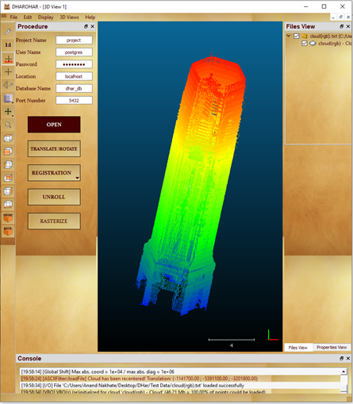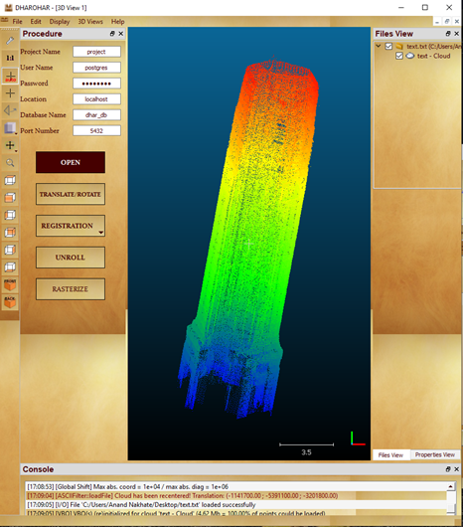

Figure: The left image represents the point cloud in a high resolution and the right one in low resolution

Sometimes, the user may wish to study only a certain segment of the point cloud. Also he may want a high resolution view of a very large data which might not open in the processing window because of memory allocation problems. For this users have the option of viewing only a portion of the point cloud data. This portion is called sub-plot. Sub-plot can be viewed and analyzed by filtering the points based on the requirement of the user.

The coordinates of extreme points are given by observing a low resolution image of the point cloud in an interactive 3d scatter plot supported by matplotlib library of python. The plot in python is an interactive plot where one can change the orientation of the plot and the coordinates are viewed at the bottom right corner of the plot. Once the user double clicks on the plot, input boxes appear where the user can enter the desired coordinates to view a subplot of the point cloud. All the points enclosed within the 3D box defined by the lines X = min(x), X = max(x), Y = min(y), Y = max(x), Z = min(z) and Z = max(z) are retrieved with the help of Point cloud functions. An input file containing all these points is then generated. This can then be analyzed in point cloud processing. The figure below is an example of an interactive scatter plot.

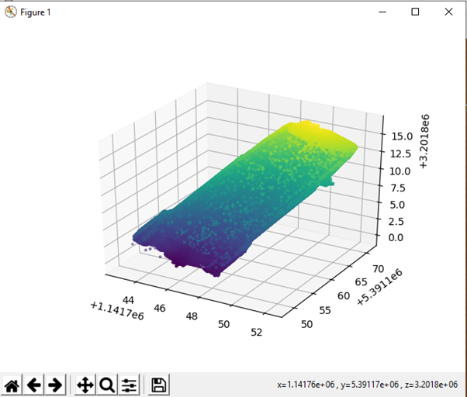

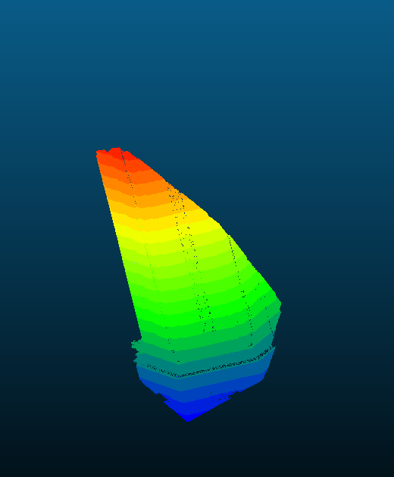

**Our Approach:**

**Storage:** The LiDAR dataset of the point cloud is available to the user in formats such as .txt, . pts, .ptx .xyz etc. which is exported from the Laser Scanner. The characteristics of data available in different formats may vary based on the export method as well as on the type of scanner used. The data can contain columns such as the coordinates, X, Y, Z, the intensity of the colors of Red, Green and Blue, Intensity of the Laser beam , Return Number and so on.

This data is first stored into the database table which is created based on the characteristics of the dataset of the user. This table created is a temporary table and is named as <project name>_<file name>_points. A unique ‘pcid’ or the ‘point cloud identifier’ is assigned to the data which will be used to call the appropriate schema from the pointcloud_formats table. This data is then converted into pc_points format where all the columns are truncated into one hexadecimal string and is inserted into a temporary table <project name>_<file name>_points.

This points in the points table is grouped by the patch level given by the user and is converted into patches where the grouped points are converted into a patch and these patches are stored in the final table <project name>_<file name>_patches. All the LiDAR data given by the user is now converted into patches and is stored into the database table without loss of any information but the size is reduced to one-fourth of the original data .

**Retrieval:** The LiDAR data which is stored in the patches format should be converted back to human readable JSON format to undergo further processing. So the data stored in patches is first exploded to obtain the points and is stored in a text file on the desktop. The data can be obtained in two types, a high resolution data and a low resolution data based on the input given by the user.

If user selects to view the data in a high resolution format, if the number of points are greater than 128 Million points, all the points are returned back else the data is obtained will consist of 128 Million points by selecting the points without any bias. This data is inserted back to a points table in the database. This data is converted back into the human readable format and then stored back into the file for further processing. If the user selects Low Resolution Mode, user has to select the level of resolution from a drop down list. Based on this, data is retrieved from the database with a maximum of one point from each patch and a minimum size of 1/(patch level *5) of the data.

The user also has an option to view only a subplot of the point cloud data. For this, once the user selects the file that needs to be viewed, an interactive python plot is displayed to the user with the coordinates of the selected point being viewed on the bottom right corner of the plot. . On double-clicking on the plot, input dialog box appears where the user can input the X(min),Y(min),Z(min) and X(max), Y(max), Z(max) and the data from that part of the point cloud gets filtered and stored in the text file which can be viewed for further processing.

**POINT CLOUD PROCESSING**

After getting permission from Admin, the user can use Point Cloud processing. Point Cloud processing involves five steps which are discussed below.

**Visualization of Point Cloud**

Point Cloud can be visualized when the user clicks on the open button. This button filters and shows all the Point Cloud Data available for visualization.

**Translation and Rotation**

Translation refers to the rigid transformation of the plane that shifts every point present in the point cloud to a fixed distance in a given direction. For translation, the User needs to select a Point Cloud. Translation is required to align the point cloud with the reference point cloud for the purpose of registration and geo-referencing.

Rotation is a transformation which turns a point cloud about a fixed point, C, called the center of rotation. When working in the coordinate plane, the center of rotation should be specified, and it is not assumed to be at the origin. The point cloud can be rotated with the angle of rotation α, β, γ along x, y and z-axis. During rotation, every point is moved to the same degree arc along the circle defined by the center of the rotation and the angle of rotation.

**Registration**

Image registration is the process of aligning two or more images of the same scene. This process involves designating one image as the reference image, also called the fixed image, and applying geometric transformations or local displacements to the other images so that they align with the reference. Registration is required as laser scanners have a typical range of a few hundred meters and cannot cover a large area. So scans of small areas are done which are then integrated with the help of Registration. The point cloud of these areas are at a different angle and are correctly matched through Registration.

Registration is done in two ways:

1. Point Pair Registration -In this, Pairing between points is known, and closed form (analytic) solutions (Horn Point Cloud Registration Method) are used.

2. Fine Registration - Pairing between points is unknown and iterative solutions (require initialization and only guarantee convergence to a local optimum) are needed. The iterative solution used in DHAROHAR is ICP (Iterative Closest Point) algorithm.

**Unroll**

This method unrolls a point cloud from a cylinder (or conical) shape onto a plane. In order to unroll a cylindrical shape, certain parameters need to be specified. These are the Axis of Revolution, Cylinder Radius and a point on the axis. Similarly, to unroll a conical shape, the required parameters are the Axis of revolution, the half angle in degrees and the cone apex position in 3D. The parameters for a straightened conical shape include the Axis of revolution, the apex position of the cone and the base radius of the 'straightened' cone, which is equal to that of the cylinder.

**Rasterization:**

The primary purpose of this tool is to rasterize a point cloud, i.e., convert it to a 2.5D grid and then export it as a new image to perform further image processing. Rasterization is the task of taking an unrolled point cloud and converting it into a raster image (pixel or dots) and then storing it in any format. In normal usage, the term refers to the rasterization of 3D models onto a 2D plane for display on a computer screen is often carried out by fixed function hardware within the graphics pipeline.

Rasterization solves the visibility problem. Visibility refers to being able to recognize which parts of 3D objects are visible to the camera. Some objects can be obstructed because they fall outside the camera's visible area or are hidden by other objects. Rasterization decomposes the image to one flat layer but limits the ability to edit.

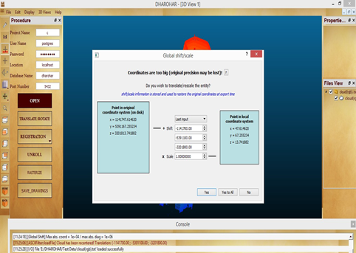

Fig 20: Open the point cloud

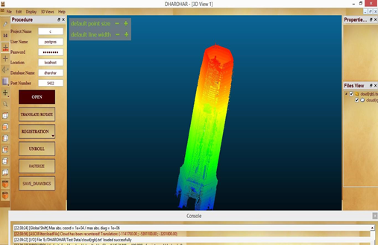

Fig 21: Opened point cloud

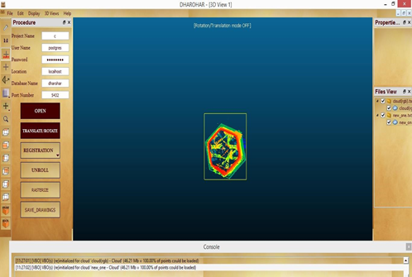

Fig 22:Translate/Rotate the clouds to unroll

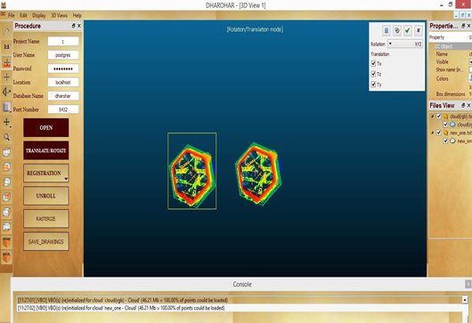

Fig 23:Separate the cloud by selecting one of them

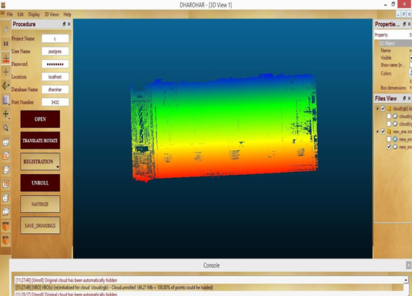

Fig 27:Unrolled point clouds

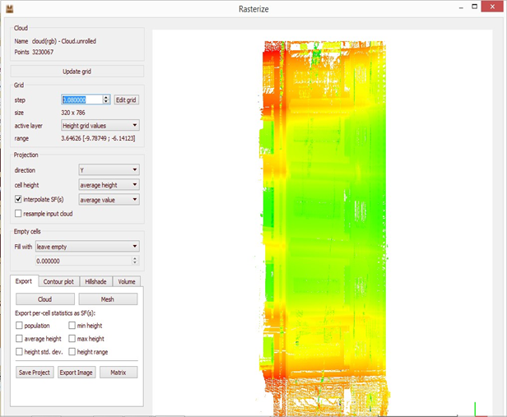

Fig 29:Save rasterize data to database

**CHANGE DETECTION**

User may also wish to detect any change between the two cloud image taken over different times. Change detection is a feature used for this purpose. In this, the user has to input two images taken at different times. It detects the difference between them which helps to find the change that has occurred over that period of time. In DHAROHAR, the predefined function of OpenCV library calculates the difference between two input test images by using subtract function which calculates the perelement difference between two arrays or array and a scalar.

User has to load Pre and Post Image from the database by providing the image ID and then the change is detected and is displayed in a new window.

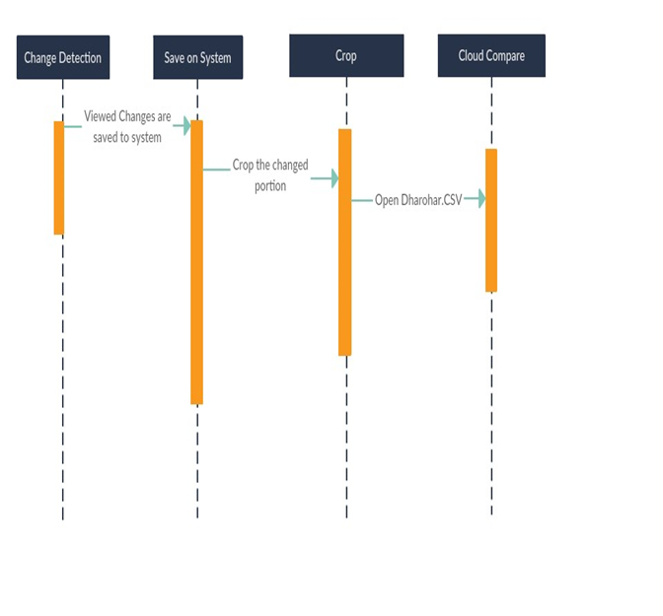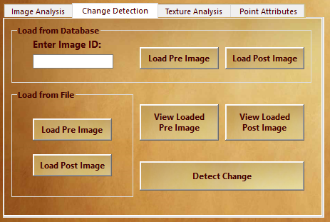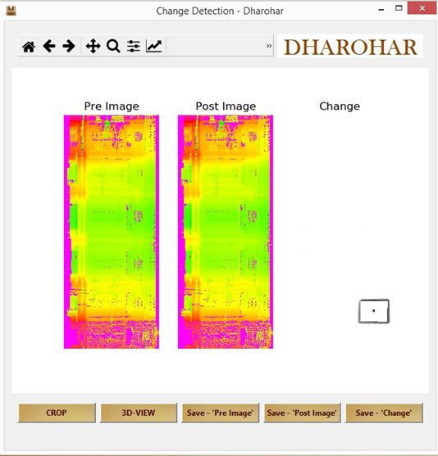

**5. GLCM TEXTURE ANALYSIS FOR 2D RASTER:**

Texture consists of texture primitives or texture elements,sometimes called texels. Texture can be described as fine, coarse, grained, and smooth, etc.

Such features are found in the tone and structure of a texture. Tone is based on pixel intensity properties in the Texel, while structure represents the spatial relationship between texels. If texels are small and tonal differences between texels are large a fine texture results. If texels are large and consist of several pixels, a coarse texture results.

GLCM texture analysis comes under Second order measures which measures the likelihood of observing a pair of grey value that occur a specified distance and direction or orientation in a part of image. Statistics considers relationship between groups of pixels in the original image and is computed on matrices derived from original image.

A gray level co-occurrence matrix (GLCM) contains information about the positions of pixels having similar gray level values.

A co-occurrence matrix is a two-dimensional array, P, in which both the rows and the columns represent a set of possible image values.

A GLCM Pd [i, j] is defined by first specifying a displacement vector d= (x, y) and counting all pairs of pixels separated by having gray levels i and j. The GLCM is defined by:

– Where nij is the number of occurrences of the pixel values (i, j) lying at distance d in the image.

– The co-occurrence matrix Pd has dimension n× n, where n is the number of gray levels in the image.

To find GLCM TEXTURE we must follow the algorithm whose steps are:

* The image at first is split into 3 three color band, Red(R Band), Green(G Band), Blue(B Band).
* The initial inputs required are the
* The **Color Band** to be used : ***R, G, B***
* The Relative **distance** between the pixel pair : ***d***
* The Relative **orientation** / rotational angle : ***θ (****0º, 45º, 90º, 135º****)***
* The window size : **W**

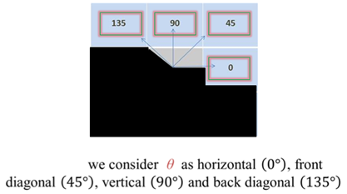

* Count all pairs of pixels in which the first pixel has a value ***i***, and its matching pair displaced from the first pixel by **d** has a value of ***j***, in direction of angle ***θ,*** for the selected color band.
* This count is entered in the **ith** row and **jth** column of the matrix Pd **[i, j]**
* Note that Pd **[i, j]** is not symmetric, since the number of pairs of pixels having gray levels **[i, j]** does not necessarily equal the number of pixel pairs having gray levels **[i, j].**

To understand the framework of GLCM we need to understand the concept that how GLCM works-

GLCM texture considers the relation between two pixels at a time, called the **reference** and the **neighbor** pixel. Each pixel within the window becomes the reference pixel in turn, starting in theupper left corner and proceeding to the lower right. Pixels along the right edge have no right hand neighbor, so they are not used for this count.

* Gray level co-occurrence matrices capture properties of a texture but they are not directly useful for further analysis, such as the comparison of two textures.
* Numeric features are computed from the co-occurrence matrix that can be used to represent the texture more compactly.

**From this matrix, generate a list of features:**

–Contrast

–Dissimilarity

–Homogeneity

–Angular second moment

–Energy

–Entropy

**Contrast:**

***Contrast*** is a measure of the local variations present in an image. Also called sum of squares variance.

**Pi,j (i - j)2**

If there is a large amount of variation in an image the **P [i, j]** ‟s will be concentrated away from the main diagonal and contrast will be high.

**Dissimilarity:**

In the Contrast measure, weights increase exponentially (0, 1, 4, 9, etc.) as one moves away from the diagonal. However, in the dissimilarity measure weights increase linearly (0, 1, 2,3 etc.)

$\sum_{i,j = 0}^{N - 1}{}$**Pi,j |i - j|**

**Homogeneity** (also called the **"Inverse Difference Moment"**):

Dissimilarity and Contrast result in larger numbers for more contrast windows. If weights decrease away from the diagonal, the result will be larger for windows with little contrast.

Homogeneity weights values by the inverse of the Contrast weight, with weights decreasing exponentially away from the diagonal:

**(Pi,j / (i - j)2)**

**Angular Second Moment (ASM):**

ASM uses as a weight for itself. High values of ASM occur when the window is very orderly.

**P2i,j**

**Energy (Uniformity):**

This feature returns the sum of squared elements in the GLCM. Range = [0 1] : Energy is 1 for a constant image. The property Energy is also known as uniformity, uniformity of energy, and square root angular second moment.

Energy = $\sqrt{ASM}$

**Correlation:**

Returns a measure of how correlated a pixel is to its neighbour over the whole image. Range = [-1 1] : Correlation is 1 or -1 for a perfectly positively or negatively correlated image. Correlation is NaN for a constant image. This feature measures the joint probability of occurrence of the specified pixel pairs.

$\sum_{i,j = 0}^{N - 1}{}$ Pi,j ((i - )(j - ) / σ2)

# Texture Analysis 2D results: On Red Band

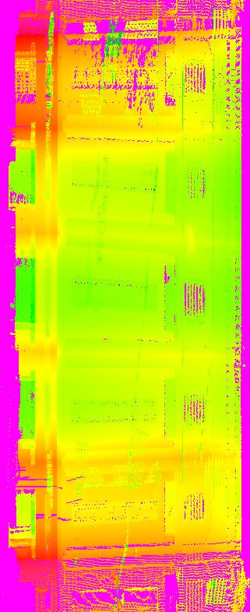 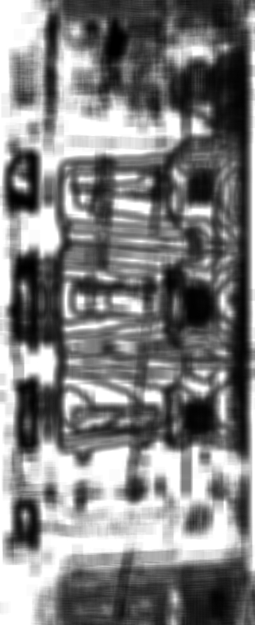 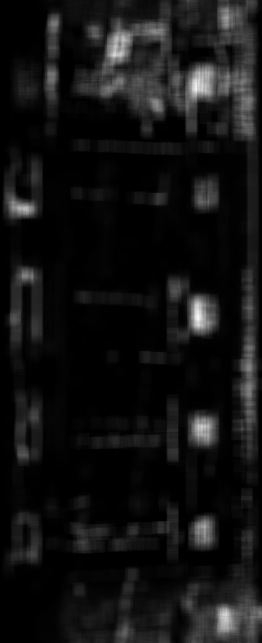 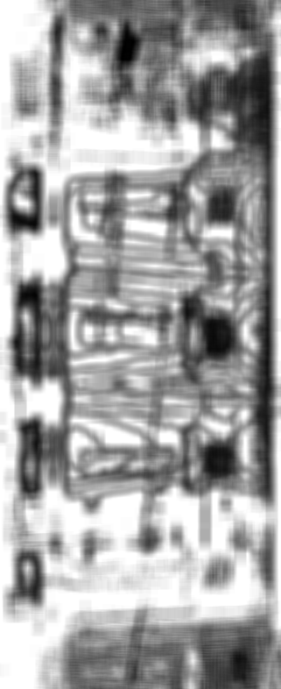

Raster Image generated on the basis of height and depth values

ASM

Contrast

Energy

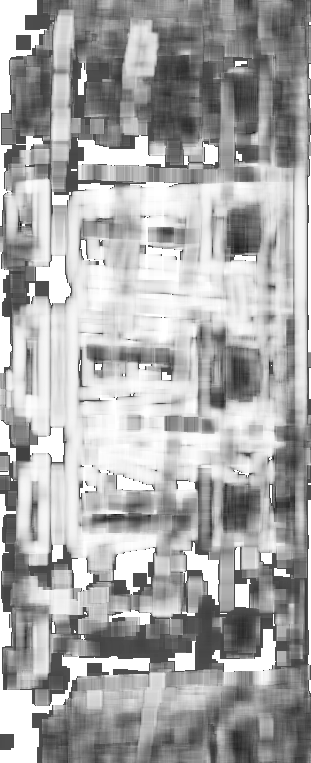 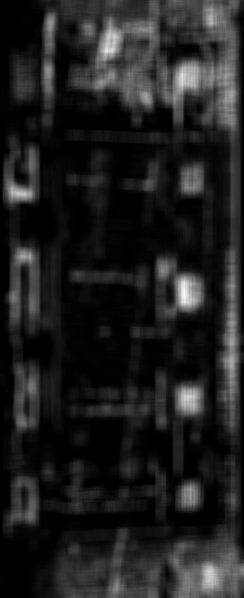 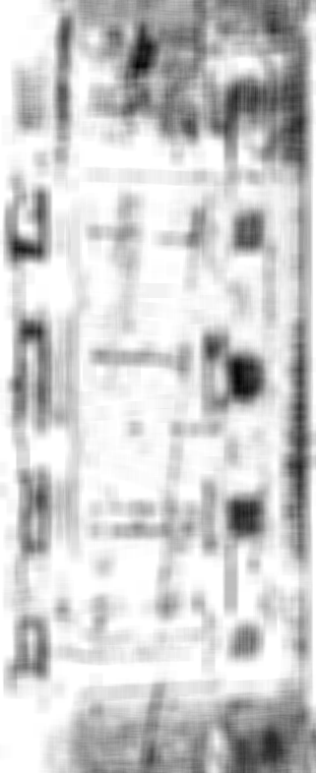

Correlation

Dissimilarity

Homogeneity

**6. GLCM TEXTURE ANALYSIS FOR 3D POINT CLOUD DATA:**

Texture analysis is applied on 2D images for further feature extraction and features isolation. The feasibility of texture analysis on volumetric data such as point cloud was tested. Our methodology was to extend 2D GLCM Texture Analysis to 3D datasets. This was done in the following way :-

* 3D point cloud data is converted to a voxel grid of suitable size and then converted to a 3D matrix from the dataframe from the voxel grid.
* Then a 3D window is run through the matrix to calculate GLCM matrix and using the GLCM matrix texture features are calculated.
* The features are then mapped to the voxel grid and then further mapped to the individual points of the point cloud.

**Voxelization of Point Cloud**

Voxelization of point cloud is the process of conversion of three dimensional points in an unordered continuous space to an ordered space of three dimensional grid that best approximates it.

The method works by taking the size parameters as input. The size parameters are used to divide the axis into corresponding sizes. Then the individual points of the point cloud are distributed into the formed voxels. This returns three arrays with the indices of the points in the voxel grid.

The voxel grid thus formed is then converted to three dimensional matrices which is the required data structure to perform GLCM analysis.

**3D GLCM Analysis**

The 3D GLCM analysis is similar to 2D GLCM analysis outlined above in the report. The only differences are instead of a 2D window, a 3D window is moved through the elements of the 3D matrix and the GLCM pairs are calculated by their distances in three dimensions. The rest process of calculating the textual features is exactly the same as the GLCM thus formed is two dimensional matrix.

The matrix M is nxn dimensional matrix and Values of the matrix elements within a moving box W at a given displacement d=(dx, dy, dz) -

M(i, j)=Wz−dz∑z=1Wx−dx∑x=1Wy−dy∑y=1CONDITION

CONDITION=(G(x, y, z)=i∧G(x+dx,y+dy,z+dz)=j)?1 : 0

**Results**

The Python Code was tested on the Clock Tower Point Cloud data with approximately 32,00,000 points and a single feature extraction took 45 minutes even at relatively high voxelization. So the process requires a huge amount of compute as even the 2D GLCM analysis is very compute intensive task with a time complexity of O(n2 * k2 * w2) where n is the number of pixels, k is the number of levels of intensity, w is the window size and therefore for 3D GLCM analysis to be feasible a different approach must be undertaken which minimises the accuracy but improves the time complexity.

**Limitations**

* The literature on direct feature extraction on 3D point cloud data using texture analysis is limited. All the application in this field are related to isolating specific objects such as organs etc from volumetric datasets. None of the methods try to achieve general feature extraction.
* The process took a lot of time and was computationally very expensive. Therefore it was not integrated into the Dharohar application as it is not practically feasible but it is the starting point for further improvements to this method.

Some **suggestions** to improve this method is to code in Cython and then use as module in Python and to try a different calculation structure instead of GLCM.

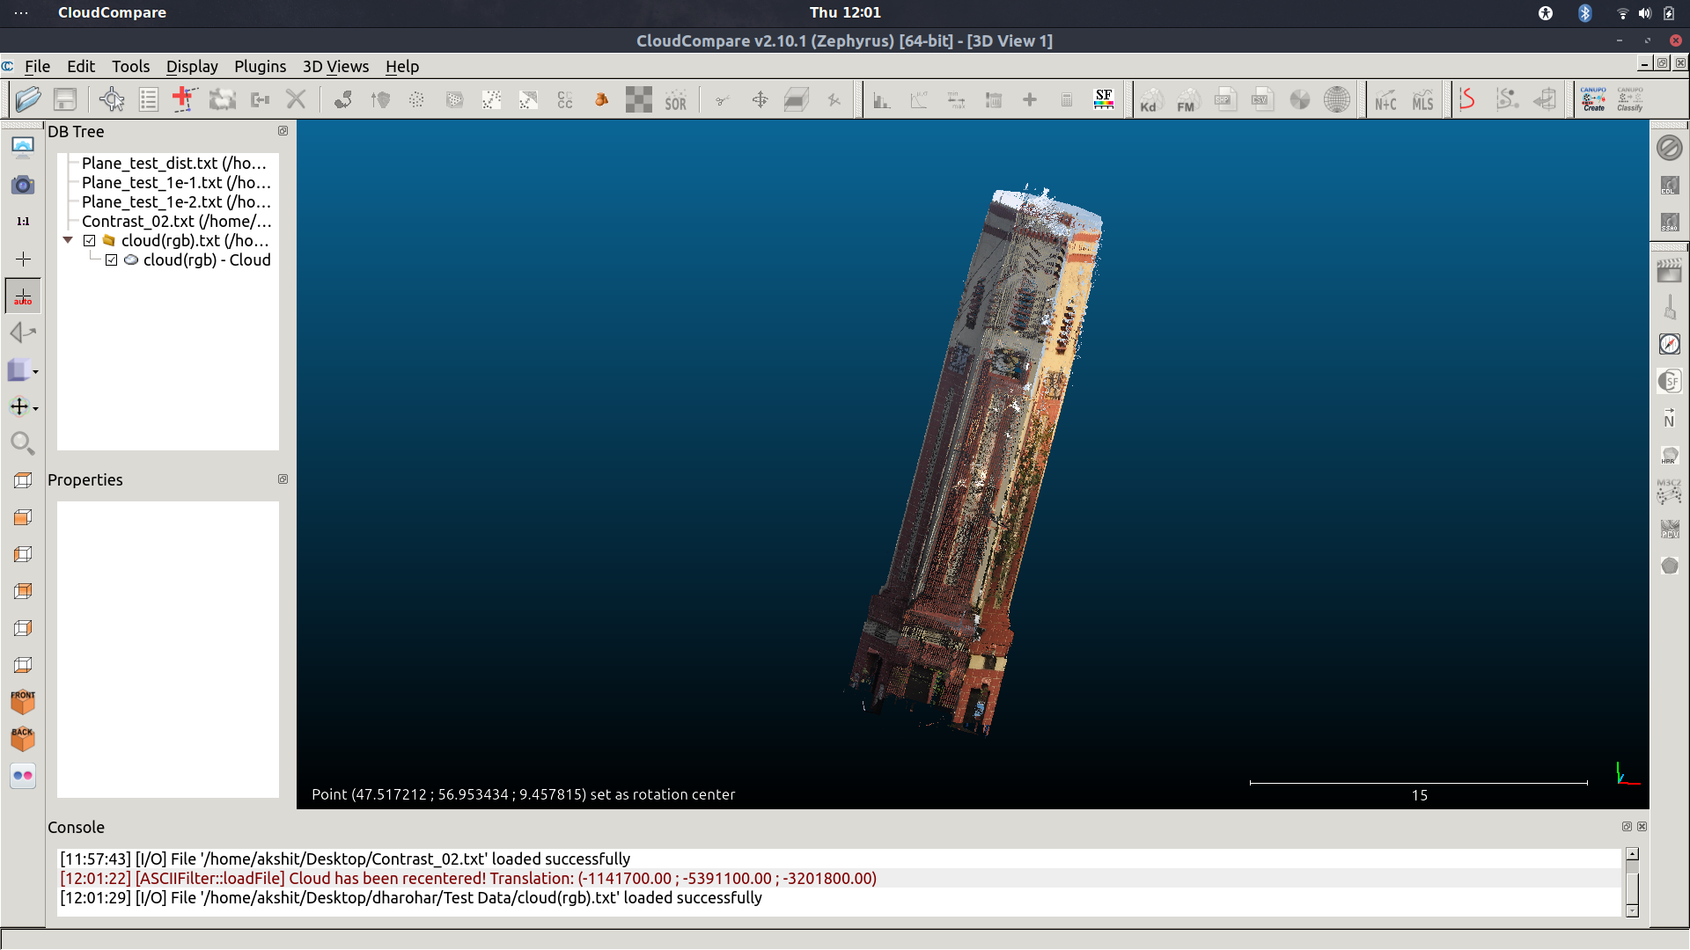

RGB Point Cloud Data of Clock Tower

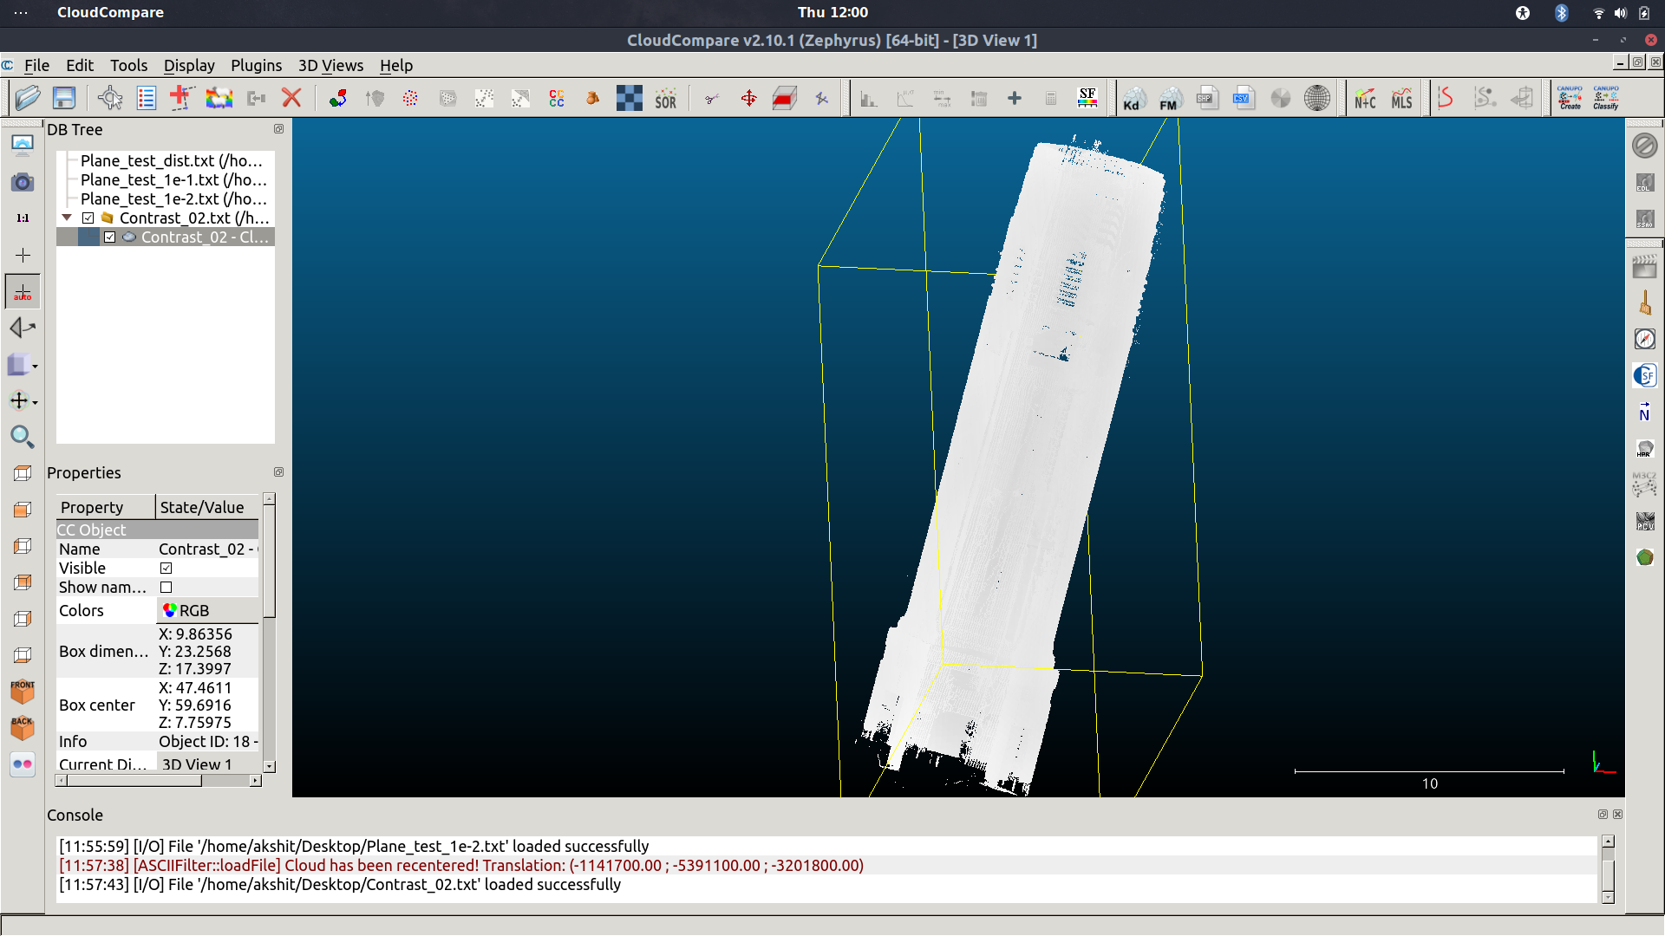

Contrast Feature of the Point Cloud (Overly White due Low Scale Voxelization)

**CODE SNIPPETS**

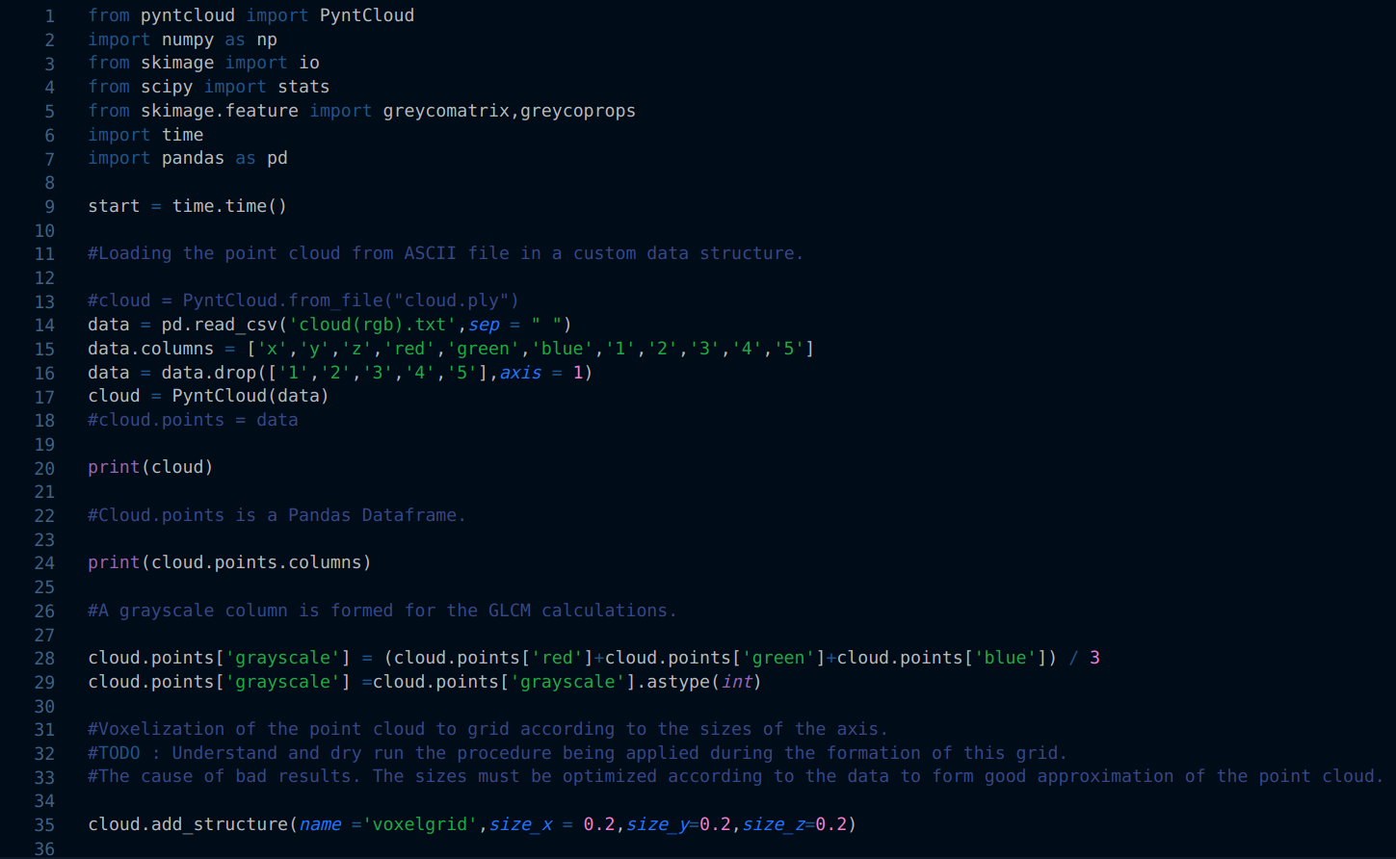

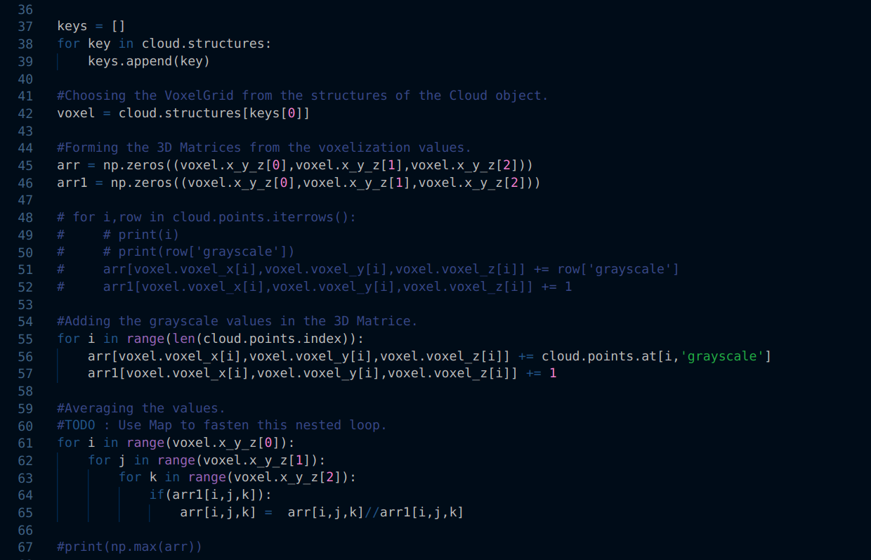

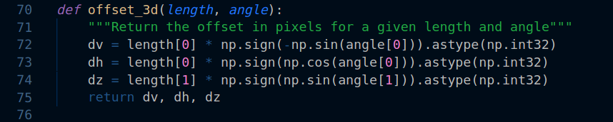

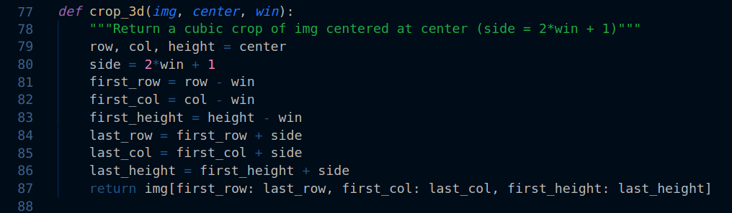

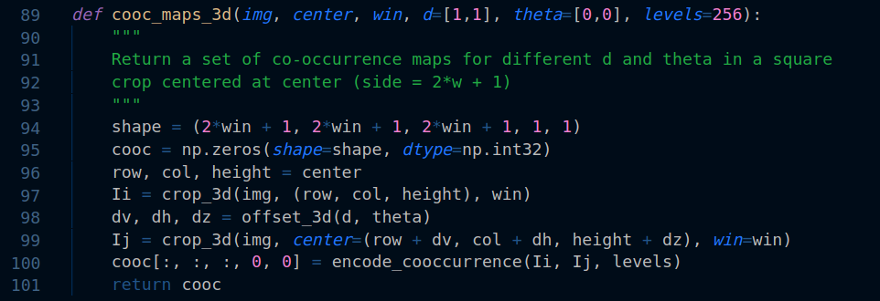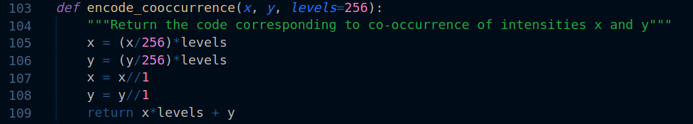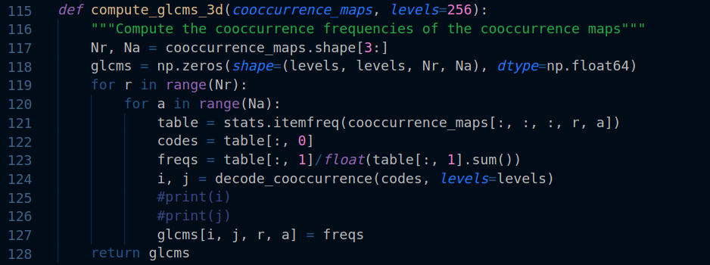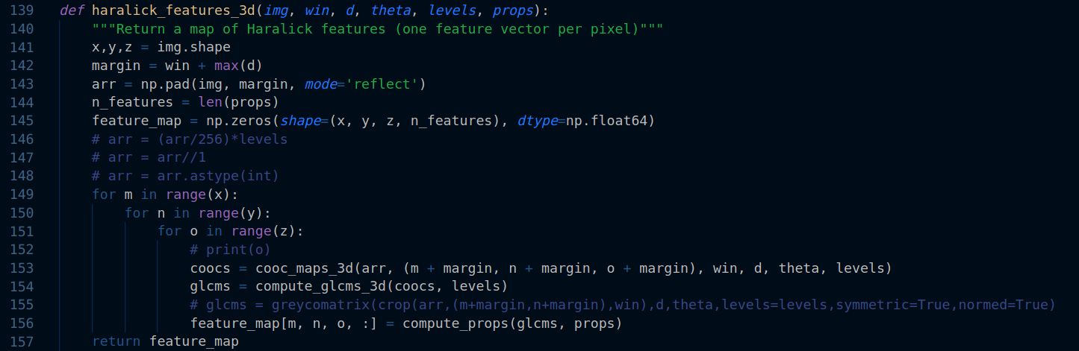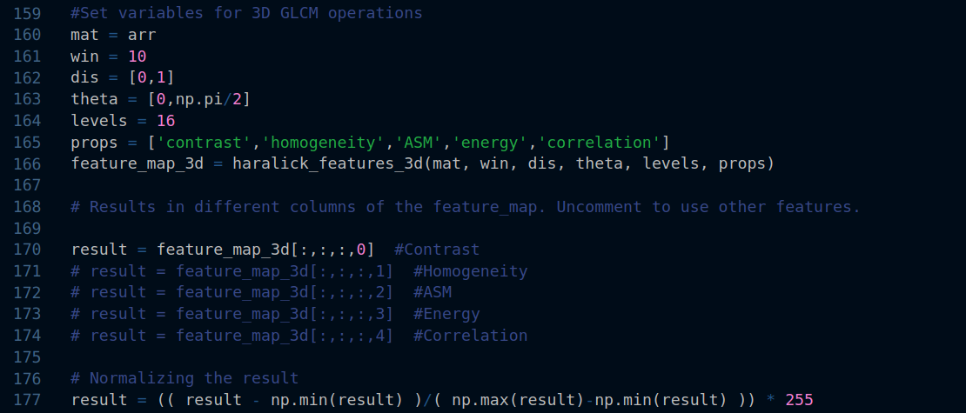

**7. PLANE FITTING ON 3D POINT CLOUD DATA**

Plane fitting on point cloud has been done using Random Sample Consensus(RANSAC) algorithm and Principal Component Analysis(PCA) to find the best fit plane in the point cloud data.

**Ransac Algorithm on point cloud data**

RANSAC was introduced by Fischer and Bolles in 1981 and is widely used for shape detection. The RANSAC algorithm mainly involves performing two iteratively repeated steps on a given point cloud: generating a hypothesis and verification. First, hypothesis shapes are generated by randomly selecting a minimal subset of n points and estimating the corresponding shape-model parameters. A minimal subset contains the smallest number of points required to uniquely estimate a model; for example, 3 points are needed to determine a plane. Then, the remaining points in the point cloud are tested with the resulting candidate shapes to determine how many of the points are well approximated by the model. After a certain number of iterations, the shape that possesses the largest percentage of inliers is extracted and the algorithm continues to process the remaining data. The plane is often fitted by the least-squares (LS) method, but this approach is often not robust to outliers when detecting planes repeatedly.

**Best Fit Plane using Principal Component Analysis**

Principal Component Analysis, or PCA, is a dimensionality-reduction method that is often used to reduce the dimensionality of large data sets, by transforming a large set of variables into a smaller one that still contains most of the information in the large set.

The covariance matrix of the points selected during RANSAC is calculated and then the eigenvalues as well as eigenvectors are calculated. The first two eigenvectors with the larger eigenvalues span the plane and the third eigenvector is the normal of the plane. Therefore with the normal and the centroid of all the points we get the equation for the best fit plane.

Right now we have implemented the plane fitting on the point cloud data upto varying minimum distance of the points from the plane -

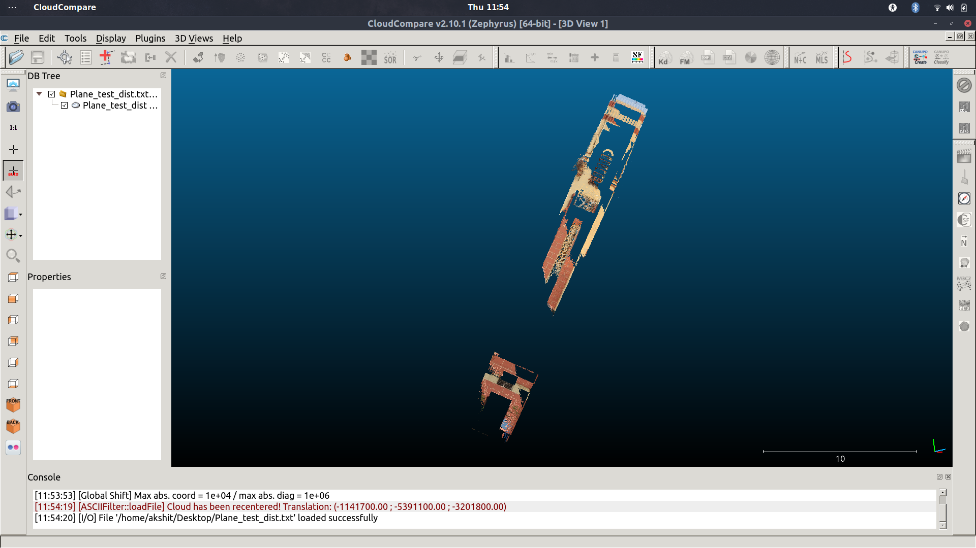

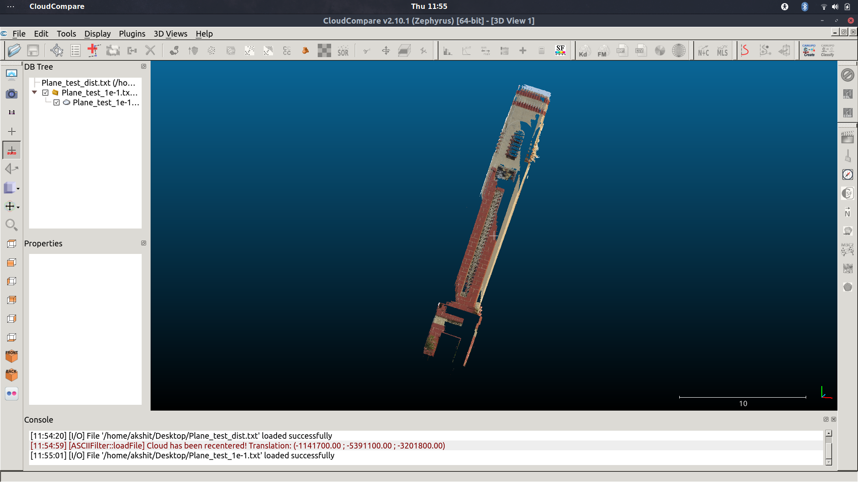

Figure - 1 Minimum Distance - 1e-2 , Figure - 2 Minimum Distance - 1e-1

The Minimum Distance set in the plane fitting algorithm is used to decide the number of inliers in the plane and is used to extract the points behind the plane. These points can be used for detection of cracks by checking the outliers for depth and using edge detection on orthoimage of the point cloud to better predict the crack probability.

**CODE SNIPPETS**

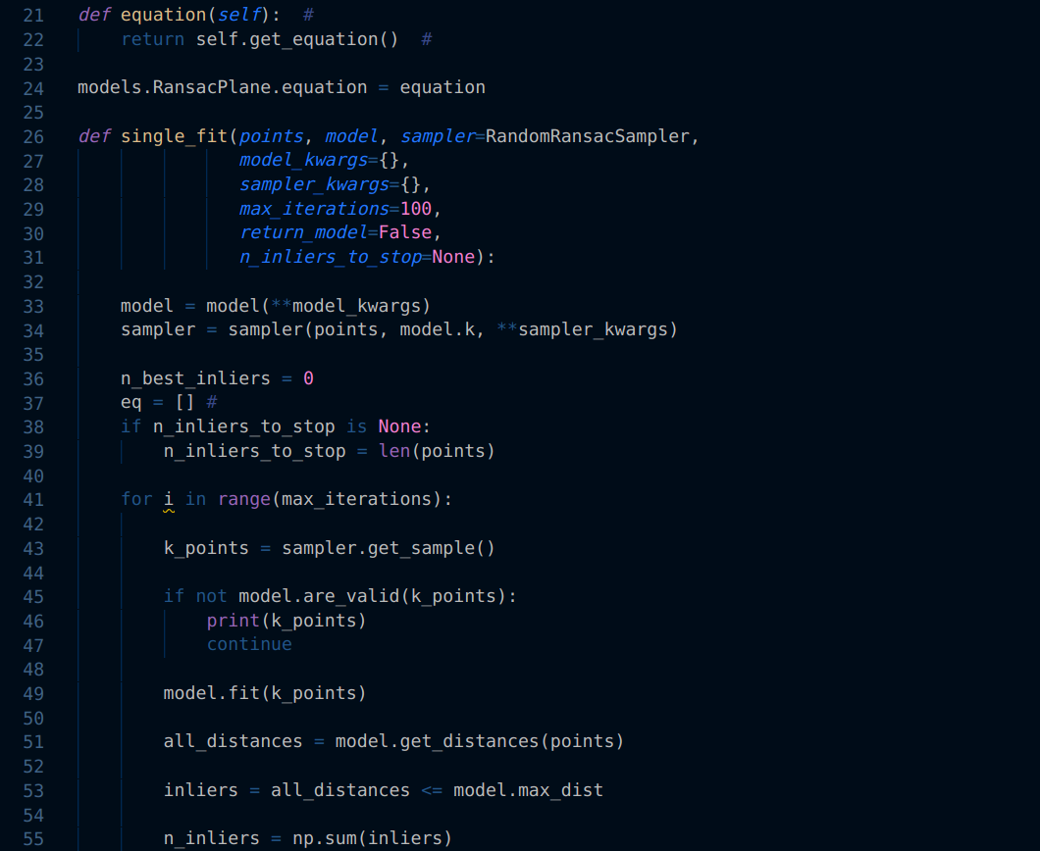

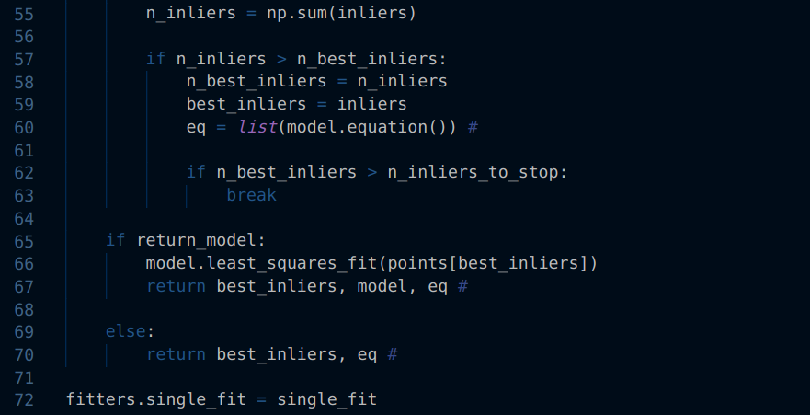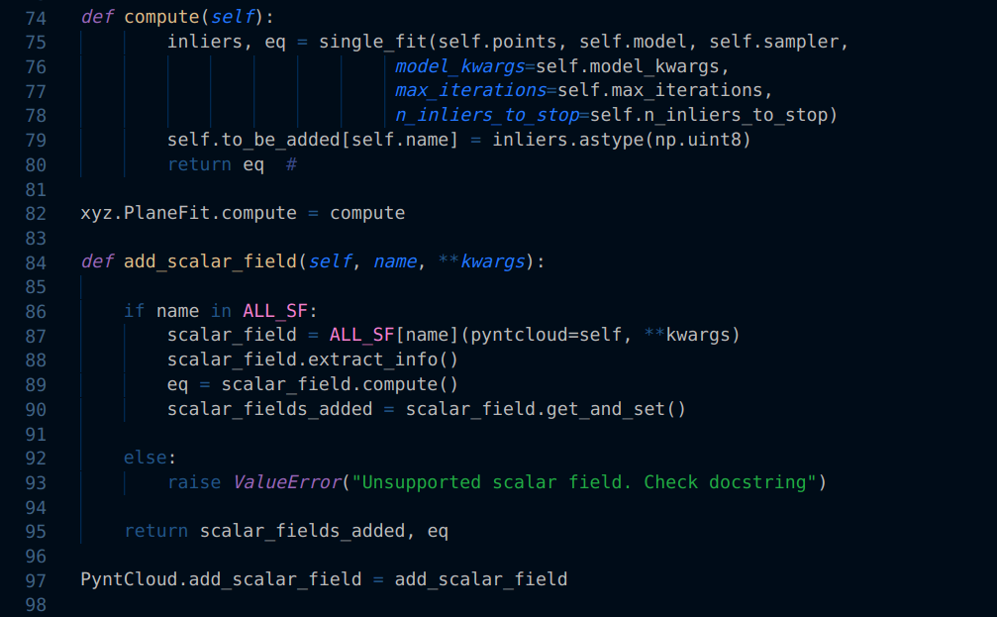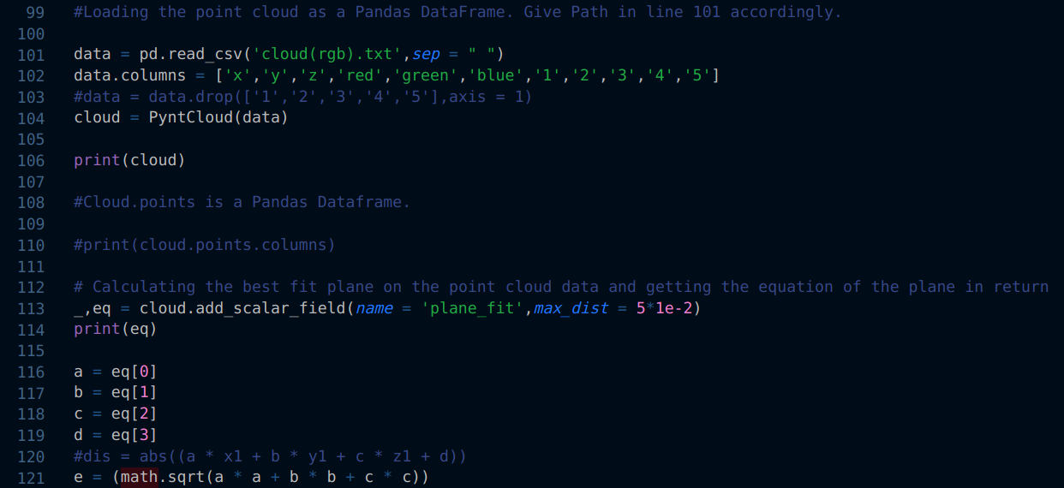

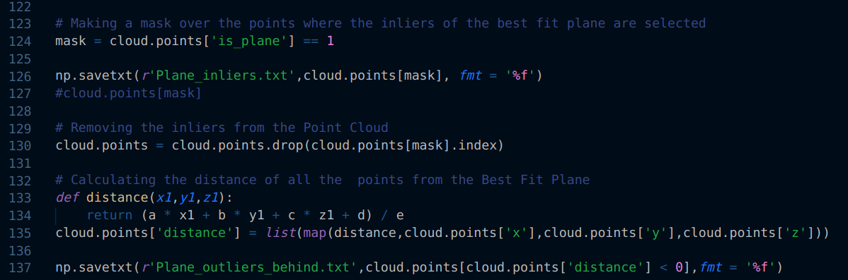

**8.1 Admin Activity Diagram**

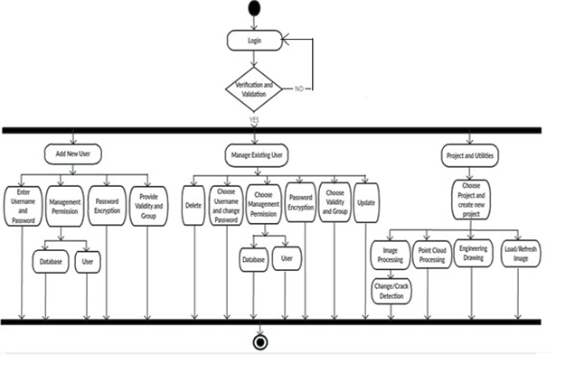

**8.2 High Level System Design**

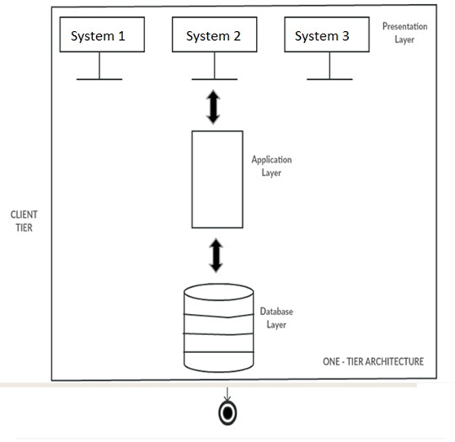

**8.3 User Case Diagrams  
User**

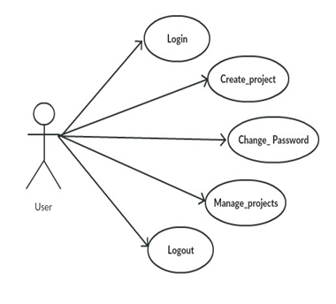

**Administrator**

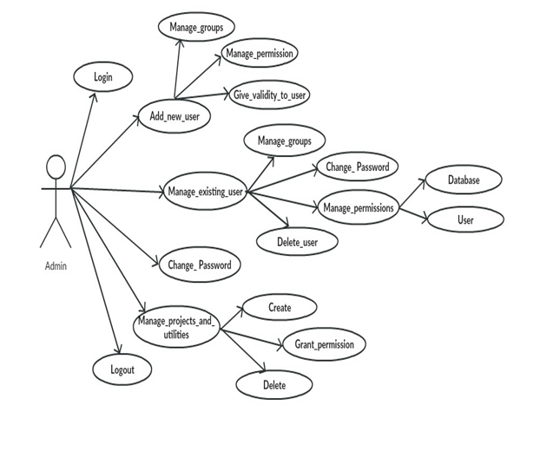

**9. Appendix**

**User Interface and WorkFlow:**

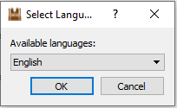

Fig : Language Selection

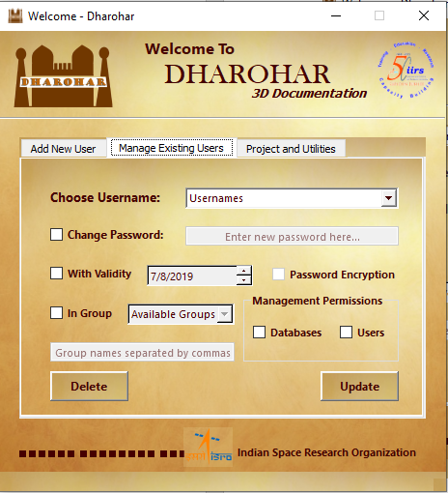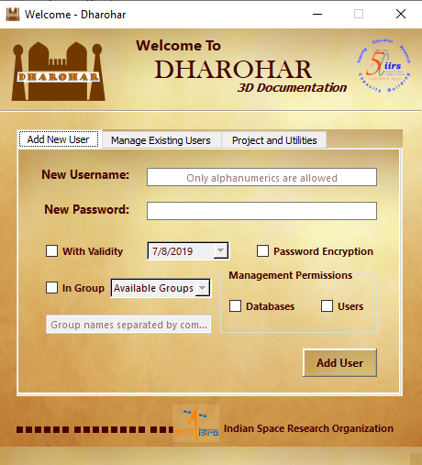

Fig: and Fig: Adding New user and Managing existing users

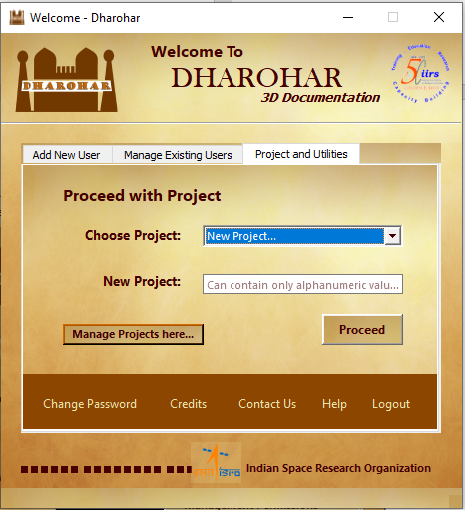

Fig: Create a new project or select from existing projects

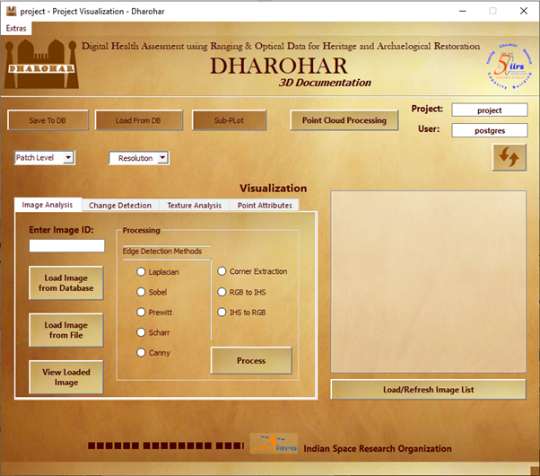

Fig: Main Window Visualization of the software

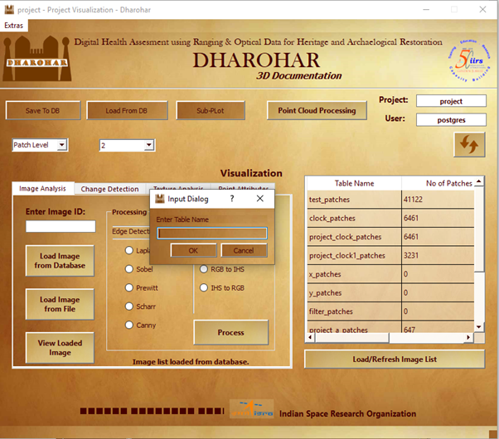

Fig: Viewing the tables for buttons Load From DB and Sub-Plot

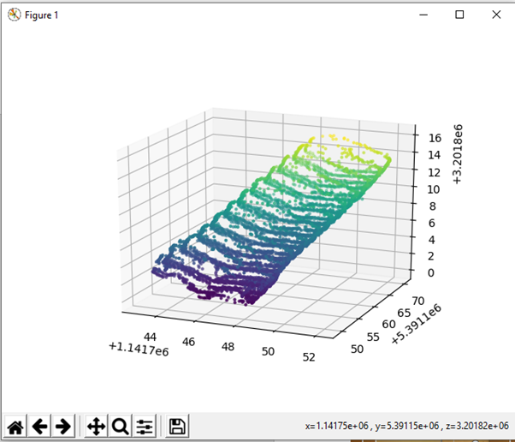

Fig: Python plot for point cloud visualization for the button Subplot

**Appendix**

**Code for 2D GLCM:**

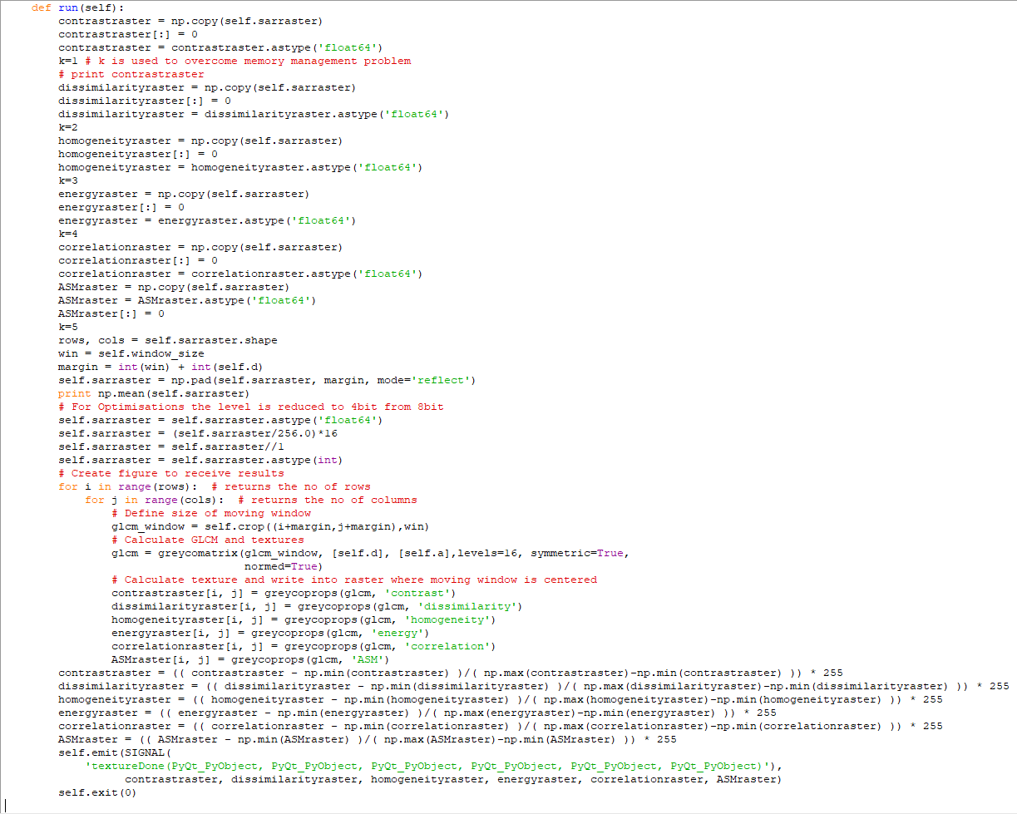

**Code to Save the Data into Database**

def saveptcld(self):

#Connecting to the database

self.conn = psycopg2.connect(database=self.db, user=self.username, host=self.host, password=self.password,

port=self.port)

self.cursor = self.conn.cursor()

#Taking an Input file form the user

try:

filename = str(QtGui.QFileDialog.getOpenFileName(self, 'Open file', '', 'TextFiles(*.txt *.csv '

'*.bmp *.tif)', None,

QtGui.QFileDialog.DontUseNativeDialog))

base=os.path.basename(filename)

fname=os.path.splitext(base)[0]

if (filename==''):

self.close()

s = open(str(filename))#Getting the filename

lines = s.readline()

a=lines.count(',')

s.close()

c=''

q = str(self.comboBox_2.currentText())

if (q=='Patch Level'):#Selecting the Patch Level

self.lblImgAnalysisNoti.setText('select patch level and try again!')

QtGui.QMessageBox.about(self,'Warning!!!','Please Select Patch Level!!!')

else:#Creating a table to store raw data

for i in range (0,a):

c=c+'c'+str(i+1)+','

c=c+'c'+str(i+2)

if (i+2 == 3):

query="CREATE unlogged TABLE " + self.project + '_' + str(fname) + " (c1 numeric, c2 numeric, c3 numeric)"

self.cursor.execute(query)

elif ( i+2==6):

query="CREATE unlogged TABLE " + self.project + '_' + str(fname) + " (c1 numeric, c2 numeric, c3 numeric, c4 numeric , c5 numeric, c6 numeric)"

self.cursor.execute(query)

elif(i+2==7):

query="CREATE unlogged TABLE " + self.project + '_' + str(fname) + " (c1 numeric, c2 numeric, c3 numeric, c4 numeric , c5 numeric, c6 numeric, c7 numeric )"

self.cursor.execute(query)

elif(i+2==8):

query="CREATE unlogged TABLE " + self.project + '_' + str(fname) + " (c1 numeric, c2 numeric, c3 numeric, c4 numeric , c5 numeric, c6 numeric, c7 numeric , c8 numeric )"

self.cursor.execute(query)

elif(i+2==9):

query="CREATE unlogged TABLE " + self.project + '_' + str(fname) + " (c1 numeric, c2 numeric, c3 numeric, c4 numeric , c5 numeric, c6 numeric, c7 numeric, c8 numeric, c9 numeric)"

self.cursor.execute(query)

elif(i+2==10):

query="CREATE unlogged TABLE " + self.project + '_' + str(fname) + " (c1 numeric, c2 numeric, c3 numeric, c4 numeric , c5 numeric, c6 numeric, c7 numeric , c8 numeric , c9 numeric , c10 numeric )"

self.cursor.execute(query)

else:

query="CREATE unlogged TABLE "+ self.project + '_' + str(fname) + " (c1 numeric, c2 numeric, c3 numeric, c4 numeric , c5 numeric, c6 numeric, c7 numeric , c8 numeric, c9 numeric , c10 numeric , c11 numeric)"

self.cursor.execute(query)

query="copy "+ self.project + '_' + str(fname) + "(" + c + ") from '" + str(filename) +"' delimiter ','"#Storing raw data into the table

self.cursor.execute(query)

query="CREATE unlogged TABLE "+ self.project + '__' + str(fname) + "(id serial, pt pcpoint(" + str(i+2) + "))"#Creating a table to store points

self.cursor.execute(query)

if (i+2 == 3):#Storing the Points

query = "INSERT INTO "+ self.project + '__' + str(fname) + "(pt) (SELECT PC_MakePoint(3,ARRAY[x1,x2,x3]) from (select c1 as x1,c2 as x2, c3 as x3 from "+ self.project+'_'+str(fname)+") as points)"

self.cursor.execute(query)

elif ( i+2==6):

query = "INSERT INTO "+ self.project + '__' + str(fname) + "(pt) (SELECT PC_MakePoint(6,ARRAY[x1,x2,x3,x4,x5,x6]) from (select c1 as x1,c2 as x2, c3 as x3, c4 as x4, c5 as x5, c6 as x6 from "+ self.project+'_'+str(fname)+") as points)"

self.cursor.execute(query)

elif(i+2==7):

query = "INSERT INTO "+ self.project + '__' + str(fname) + "(pt) (SELECT PC_MakePoint(7,ARRAY[x1,x2,x3,x4,x5,x6,x7]) from (select c1 as x1,c2 as x2, c3 as x3, c4 as x4, c5 as x5, c6 as x6, c7 as x7 from "+ self.project+'_'+str(fname)+") as points)"

self.cursor.execute(query)

elif(i+2==8):

query = "INSERT INTO "+ self.project + '__' + str(fname) + "(pt) (SELECT PC_MakePoint(8,ARRAY[x1,x2,x3,x4,x5,x6,x7,x8]) from (select c1 as x1,c2 as x2, c3 as x3, c4 as x4, c5 as x5, c6 as x6, c7 as x7, c8 as x8 from "+ self.project+'_'+str(fname)+") as points)"

self.cursor.execute(query)

elif(i+2==9):

query = "INSERT INTO "+ self.project + '__' + str(fname) + "(pt) (SELECT PC_MakePoint(9,ARRAY[x1,x2,x3,x4,x5,x6,x7,x8,x9]) from (select c1 as x1,c2 as x2, c3 as x3, c4 as x4, c5 as x5, c6 as x6, c4 as x4, c5 as x5, c6 as x6, c7 as x7, c8 as x8, c9 as x9 from "+ self.project+'_'+str(fname)+") as points)"

self.cursor.execute(query)

elif(i+2==10):

query = "INSERT INTO "+ self.project + '__' + str(fname) + "(pt) (SELECT PC_MakePoint(10,ARRAY[x1,x2,x3,x4,x5,x6,x7,x8,x9,x10]) from (select c1 as x1,c2 as x2, c3 as x3, c4 as x4, c5 as x5, c6 as x6, c7 as x7, c8 as x8, c9 as x9, c10 as x10 from "+ self.project+'_'+str(fname)+") as points)"

self.cursor.execute(query)

else:

query = "INSERT INTO "+ self.project + '__' + str(fname) + "(pt) (SELECT PC_MakePoint(11,ARRAY[x1,x2,x3,x4,x5,x6,x7,x8,x9,x10,x11]) from (select c1 as x1,c2 as x2, c3 as x3, c4 as x4, c5 as x5, c6 as x6, c7 as x7, c8 as x8, c9 as x9, c10 as x10, c11 as x11 from "+ self.project+'_'+str(fname)+") as points)"

self.cursor.execute(query)

query="drop table "+ self.project + '_' + str(fname)

self.cursor.execute(query)

query="create table " + self.project + '_' +str(fname) + "_patches(id serial,pa pcpatch(" + str(i+2) + "))"#Creating a table to store patches

self.cursor.execute(query)

query = "INSERT INTO " + self.project + '_' + str(fname) + "_patches (pa) SELECT PC_Patch(pt) FROM "+self.project + '__'+str(fname)+" GROUP BY id/" + str(q)#Storing data in the form of patches

self.cursor.execute(query)

query="drop table "+ self.project + '__' + str(fname)

self.cursor.execute(query)

self.conn.commit()

except:

QtGui.QMessageBox.about(self,'WARNING','No File Selected!!!')

**Code to retrieve the data from the database**

def LoadFromDB(self):

desktop = os.path.join(os.path.join(os.environ['USERPROFILE']), 'Desktop\\text.txt')

path=str(desktop)

print path

self.conn = psycopg2.connect(database=self.db, user=self.username, host=self.host, password=self.password,

port=self.port)

self.cursor = self.conn.cursor()

sql = "SELECT relname,n_live_tup FROM pg_stat_user_tables where relname like '%_patches'"

header_row = ['Table Name','No of Patches']

self.queryThread = queryDatabase(sql, self.conn, header_row, True, -1, '')

self.connect(self.queryThread, SIGNAL('visualizeResult(PyQt_PyObject, PyQt_PyObject, bool, int, PyQt_PyObject, bool)'), self.visualizeResult)

self.connect(self.queryThread, SIGNAL('finished()'), self.loadImgListDone)

self.queryThread.start()

self.lblImgAnalysisNoti.setText('Loading... Please wait...')

self.btnLoadImgList.setEnabled(False)

self.btnLoadImgList.setFlat(True)

text,ok=QInputDialog.getText(self, 'Input Dialog', 'Enter Table Name')

if ok:

sql=" select pc_pcid(pa) from " + str(text) + " limit 1"

self.cursor.execute(sql)

a=self.cursor.fetchone()

b=a[0]

sql="drop table if exists " + self.project + "_test_points"

self.cursor.execute(sql)

sql="create table " + self.project + "_test_points(id serial,pt pcpoint(" + str(int(b)) + "))"

self.cursor.execute(sql)

Resolution,ok=QInputDialog.getText(self, 'Input Dialog', 'Enter L for Low Resolution or H for High Resolution')

if ok:

try:

if str(Resolution) == 'L':

q = str(self.comboBox.currentText())

if (q==' Resolution'):

self.lblImgAnalysisNoti.setText('select Resolution and try again!')

QtGui.QMessageBox.about(self,'Warning!!!','Please Select Resolution!!!')

else:

sql="copy (select pc_explode(pc_patch(pc_patchavg(pa))) from "+str(text)+ " group by id/" + str(q) + ") to '" + path + "'"

self.cursor.execute(sql)

sql="COPY " + self.project +"_test_points(pt) from '" + path + "'"

self.cursor.execute(sql)

sql="COPY (select PC_get(pt) from "+self.project+"_test_points) TO '" + path + "' DELIMITER ','"

self.cursor.execute(sql)

else:

sql="Select count(*) from " + str(text);

self.cursor.execute(sql)

l=self.cursor.fetchone()

m=l[0]

a=int(m)

sql="Select pc_numpoints(pa) from " + str(text);

self.cursor.execute(sql)

lk=self.cursor.fetchone()

lm=lk[0]

print lm

a=a*int(lm)

print a

sql="copy (select pc_explode(pa) from "+str(text)+ ") to '" + path + "'"

self.cursor.execute(sql)

sql="COPY " +self.project+"_test_points(pt) from '" + path+ "'"

self.cursor.execute(sql)

if (a>128000000):

num=(a/128000000) + 1

sql="COPY (select PC_get(pt) from " + self.project + "_test_points where id%" + str(num) + "=0) TO '" + path + "' Delimiter ','"

self.cursor.execute(sql)

self.conn.commit()

else:

sql="COPY (select PC_get(pt) from "+self.project + "_test_points) TO '" + path + "' Delimiter ','"

self.cursor.execute(sql)

self.conn.commit()

except:

QtGui.QMessageBox.about(self,'WARNING','Invalid File Name!!!')

s = open(path).read()

s = s.replace('\\', '')

s = s.replace('{', '')

s = s.replace('}', '')

f = open(path, 'w')

f.write(s)

f.close()

sql="drop table if exists " +self.project + "_test_points"

self.cursor.execute(sql)

**Code to load a Sub-Plot of a point cloud**

def filterpoints(self):

self.conn = psycopg2.connect(database=self.db, user=self.username, host=self.host, password=self.password,

port=self.port)

self.cursor = self.conn.cursor()

desktop = os.path.join(os.path.join(os.environ['USERPROFILE']), 'Desktop\\text.txt')

path=str(desktop)

sql = "SELECT tablename FROM pg_catalog.pg_tables where tablename like '%_patches' "

header_row = ['Table Name']

self.queryThread = queryDatabase(sql, self.conn, header_row, True, -1, '')

self.connect(self.queryThread, SIGNAL('visualizeResult(PyQt_PyObject, PyQt_PyObject, bool, int, PyQt_PyObject, bool)'), self.visualizeResult)

self.connect(self.queryThread, SIGNAL('finished()'), self.loadImgListDone)

self.queryThread.start()

self.lblImgAnalysisNoti.setText('Loading... Please wait...')

self.btnLoadImgList.setEnabled(False)

self.btnLoadImgList.setFlat(True)

text,ok=QInputDialog.getText(self, 'Input Dialog', 'Enter Table Name')

if ok:

try:

sql="copy (select pc_patchavg(pa,'x'),pc_patchavg(pa,'y'),pc_patchavg(pa,'z') from "+str(text)+ ") to '" +path+ "' delimiter ','"

self.cursor.execute(sql)

x = []

y = []

z = []

plt.show()

fig = plt.figure()

ax = plt.axes(projection="3d")

points=np.loadtxt(path,delimiter=',')

for row in points:

x.append(float(row[0]))

y.append(float(row[1]))

z.append(float(row[2]))

ax.scatter3D(x,y,z,s=4,c=z)

coords = []

def onclick(event):

global text1,text2,text3,text4,text5,text6,ok2,ok3,ok4,ok5,ok6,ok1

if event.dblclick:

text1,ok1=QInputDialog.getText(self, 'Input Dialog', 'X Minimum')

text2,ok2=QInputDialog.getText(self, 'Input Dialog', 'Y Minimum')

text3,ok3=QInputDialog.getText(self, 'Input Dialog', 'Z Minimum')

text4,ok4=QInputDialog.getText(self, 'Input Dialog', 'X Maximum')

text5,ok5=QInputDialog.getText(self, 'Input Dialog', 'Y Maximum')

text6,ok6=QInputDialog.getText(self, 'Input Dialog', 'Z Maximum')

if(text6!=''):

plt.close()

cid = fig.canvas.mpl_connect('button_press_event', onclick)

plt.show()

if (ok1 and ok2 and ok3 and ok4 and ok5 and ok6) :

sql=" select pc_pcid(pa) from " + str(text) + " limit 1"

self.cursor.execute(sql)

a=self.cursor.fetchone()

print a[0]

b=a[0]

sql="drop table if exists " +self.project+ "_test_points"

self.cursor.execute(sql)

sql="create table " + self.project+"_test_points(pt pcpoint(" + str(int(b)) + "))";

self.cursor.execute(sql)

sql="drop table if exists "+ self.project+ "_x_patches"

self.cursor.execute(sql)

sql="drop table if exists "+ self.project+ "_y_patches"

self.cursor.execute(sql)

sql="drop table if exists "+ self.project+ "_filter_patches"

self.cursor.execute(sql)

sql="create unlogged table " +self.project +"_x_patches ( pa pcpatch(" + str(int(b)) + "))"

self.cursor.execute(sql)

sql="create unlogged table " +self.project +"_y_patches ( pa pcpatch(" + str(int(b)) + "))"

self.cursor.execute(sql)

sql="create unlogged table " +self.project +"_filter_patches ( pa pcpatch(" + str(int(b)) + "))"

self.cursor.execute(sql)

sql="insert into " + self.project+ "_x_patches(pa) select pc_filterbetween(pa,'x'," + str(text1) + "," +str(text4) + ') from ' + str(text)+ " as values"

self.cursor.execute(sql)

sql="delete from " + self.project + "_x_patches where pa is null"

self.cursor.execute(sql)

sql="insert into y_patches(pa) select pc_filterbetween(pa,'y'," + str(text2) + ',' +str(text5) + ") from x_patches as values"

self.cursor.execute(sql)

sql="delete from " + self.project + "_y_patches where pa is null"

self.cursor.execute(sql)

sql="insert into " + self.project + "_filter_patches(pa) select pc_filterbetween(pa,'z'," + str(text3) + ',' +str(text6) + ") from y_patches as values"

self.cursor.execute(sql)

sql="delete from " + self.project + "_filter_patches where pa is null"

self.cursor.execute(sql)

sql="copy (select pc_explode(pa) from " + self.project + "_filter_patches) to '" + path + "'"

self.cursor.execute(sql)

sql="COPY " +self.project+ "_test_points from '" + path + "'"

self.cursor.execute(sql)

sql="COPY (select PC_get(pt) from " + self.project + "_test_points) TO '" + path + "' DELIMITER ','"

self.cursor.execute(sql)

self.conn.commit()

s = open(path).read()

s = s.replace('\\', '')

s = s.replace('{', '')

s = s.replace('}', '')

f = open(path, 'w')

f.write(s)

f.close()

else:

plt.close()

except:

QtGui.QMessageBox.about(self,'WARNING','Invalid File Name!!!')

else:

self.close()

**Schema for point cloud pc_patch and pc_point data formats**

INSERT INTO pointcloud_formats (pcid, srid, schema) VALUES (11, 4326,

'<?xml version="1.0" encoding="UTF-8"?>

<pc:PointCloudSchema xmlns:pc="http://pointcloud.org/schemas/PC/1.1"

xmlns:xsi="http://www.w3.org/2001/XMLSchema-instance">

<pc:dimension>

<pc:position>1</pc:position>

<pc:size>8</pc:size>

<pc:description>X coordinate as a double precision. You must use the

scale and offset information of the header to

determine the double value.</pc:description>

<pc:name>X</pc:name>

<pc:interpretation>decimal</pc:interpretation>

<pc:scale>0.00000001</pc:scale>

</pc:dimension>

<pc:dimension>

<pc:position>2</pc:position>

<pc:size>8</pc:size>

<pc:description>Y coordinate as a double precision. You must use the

scale and offset information of the header to

determine the double value.</pc:description>

<pc:name>Y</pc:name>

<pc:interpretation>decimal</pc:interpretation>

<pc:scale>0.00000001</pc:scale>

</pc:dimension>

<pc:dimension>

<pc:position>3</pc:position>

<pc:size>8</pc:size>

<pc:description>Z coordinate as a double precision. You must use the

scale and offset information of the header to

determine the double value.</pc:description>

<pc:name>Z</pc:name>

<pc:interpretation>decimal</pc:interpretation>

<pc:scale>0.00000001</pc:scale>

</pc:dimension>

<pc:dimension>

<pc:position>4</pc:position>

<pc:size>2</pc:size>

<pc:description>The intensity (r).</pc:description>

<pc:name>Intensity_r</pc:name>

<pc:interpretation>uint16_t</pc:interpretation>

<pc:scale>1</pc:scale>

</pc:dimension>

<pc:dimension>

<pc:position>5</pc:position>

<pc:size>2</pc:size>

<pc:description>The intensity (g).</pc:description>

<pc:name>Intensity_g</pc:name>

<pc:interpretation>uint16_t</pc:interpretation>

<pc:scale>1</pc:scale>

</pc:dimension>

<pc:dimension>

<pc:position>6</pc:position>

<pc:size>2</pc:size>

<pc:description>The intensity (b).</pc:description>

<pc:name>Intensity_b</pc:name>

<pc:interpretation>uint16_t</pc:interpretation>

<pc:scale>1</pc:scale>

</pc:dimension>

<pc:dimension>

<pc:position>7</pc:position>

<pc:metadata>

<Metadata name="compression">dimensional</Metadata>

</pc:metadata></pc:PointCloudSchema>');

**REFERENCES**

Dwivedi, S., Borse, R. P., & Yametka, A. M. (2014). Lung Cancer detection and Classification by using Machine Learning & Multinomial Bayesia. *Journal of Electronics and Communication Engineering*, 69-75.

GitHub. (2018, December 5). *A PostgreSQL extension for storing point cloud (LIDAR) data.* Retrieved from GitHub: https://github.com/pgpointcloud/pointcloud

MathWorks. (2019). *graycoprops*. Retrieved from MathWorks Web Site: https://www.mathworks.com/help/images/ref/graycoprops.html

Sreeraj, R., & Raju, G. (2016). Increasing Sensitivity, Specificity and PPV for Liver Tumor Segmentation and Classification Using Enhanced GLCM. *Biomedical and Pharmacology Journal*, 3-9.

Sunagar, V., Kattimani, P., Padasali, V., & Neetha, H. (2014). ESTIMATION OF NITROGEN CONTENT IN LEAVES USING IMAGE PROCESSING. *Proceedings of International Conference on Advances in Engineering & Technology*.

Tomar, A. (n.d.). *How to get started with PostgreSQL*. Retrieved from FreeCodeCamp: https://www.freecodecamp.org/news/how-to-get-started-with-postgresql-9d3bc1dd1b11/

Zaiste. (2017, February 16). *Faster INSERTs: How to increase PostgreSQL write performance*. Retrieved from Nukomeet: https://blog.nukomeet.com/faster-inserts-how-to-increase-postgresql-write-performance-24d76bd56f75